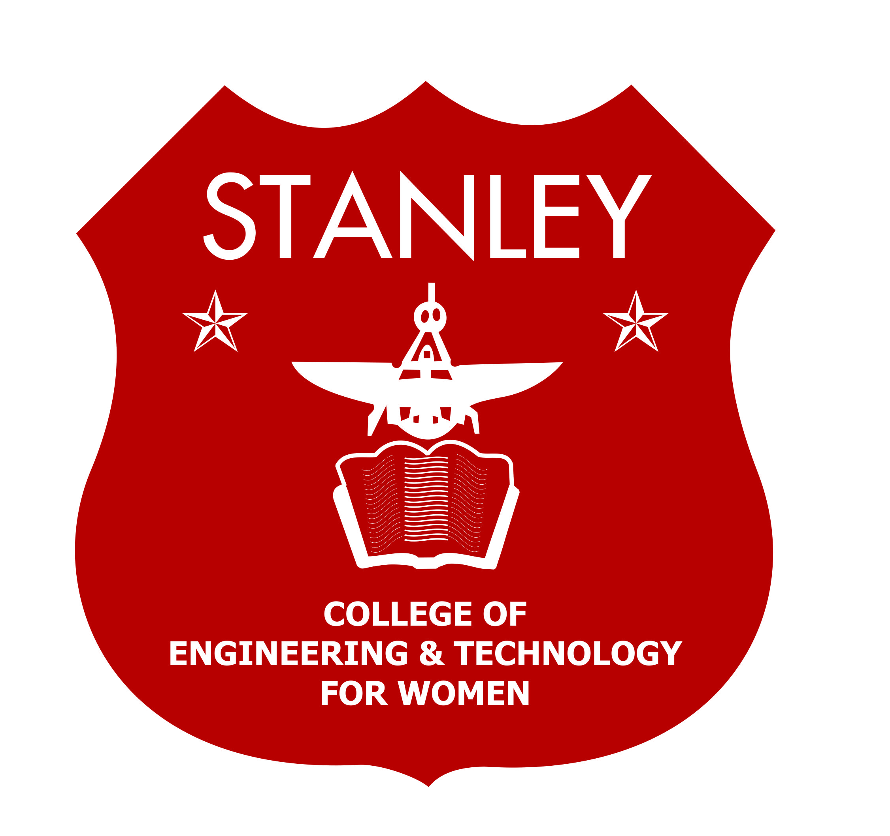
Stanley College of Engineering and Technology for Women
Chapel Road, Abids, Hyderabad – 500 001
(Autonomous)

(AUTONOMOUS)
Affiliated to Osmania University & Approved by AICTE)
(All eligible UG Courses are accredited by NBA & Accredited by NAAC with ‘A’ Grade)

(Affiliated to Osmania University & Approved by AICTE)
(All eligible UG Courses are accredited by NBA & Accredited by NAAC with ‘A’ Grade)
Department of EEE
STANFEST 2K22
2021-2022
Event Name: Short film contest.
Registration Fees: 50 Rupees per student
Date of Event: 13th May’2022.
Venue of Event: B Block Simulation lab
Timings of Event: 10:00 – 12:00PM

Guidelines for Short film Contest:

- The Shorter the Better. Usually, a short film is a movie should be between 5 -10 minutes in length. Keep it practical and minimal of selected topics.
- Films will be judged on originality, creativity, plot, pacing, and structure, characters, cinematography and entertainment value as well as on effectiveness of the message and the ability of the film maker to reach an audience.
- Tell us the truth visually.
- Engage your audience.
- Before presenting your short film on 13th may, send your video clip to the mail ID i.e stanfest2k22eee@stanley.edu.in before 11th may to avoid glitches.
Event Coordinator’s:
- Ms. Namrata Sampath (9848542179), namratha@stanley.edu.in)
- Ms. Shruthi Rao, Assistant prof (8499904444, shruthirao@stanley.edu.in)

Student Coordinator’s:
Vagdevi – VIII sem (9393933648)
Sanjana-VIII sem (9492469101)
Manogna-IV sem (9392710725)
Angel.p-VI sem (9666307909)

Faculty coordinators Convener Dr. N. Nagashekar Reddy
B. Vijayalakshmi (HOD)
M. Shruthi Rao

