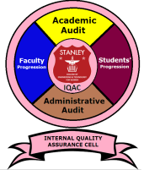
STANLEY COLLEGE OF ENGINEERING AND TECHNOLOGY FOR WOMEN
(Affiliated to Osmania University)
(Accredited by NAAC with “A” Grade, Accredited by NBA)
ABIDS, HYDERABAD- 500 001

INTERNAL QUALITY ASSURANCE CELL (IQAC)

BENEFITS

IQAC will facilitate / contribute to

- Ensuring clarity and focus in the institution’s march towards quality enhancement;
- Ensuring internalization of quality culture;
- Ensuring enhancement and coordination among the various units and activities of the institution and institutionalizing all good practices;
- Providing a sound basis for decision-making to improve institutional functioning;
- Acting as a dynamic system for quality changes in HEIs; and
- Building a sound methodology for documentation and internal communication.

