4.3.1 - Bandwidth of internet connection in the Institution
100mbs VOIS COMMUNICATION LEASED LINE and 20mbs PIONEER LEASED LINE
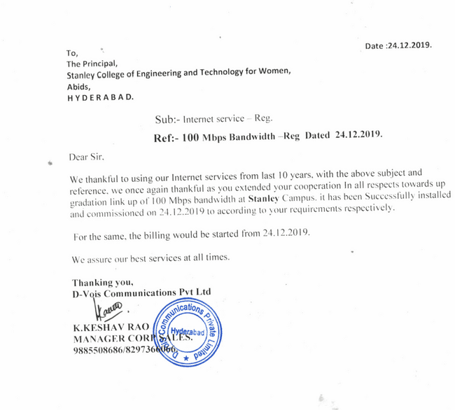

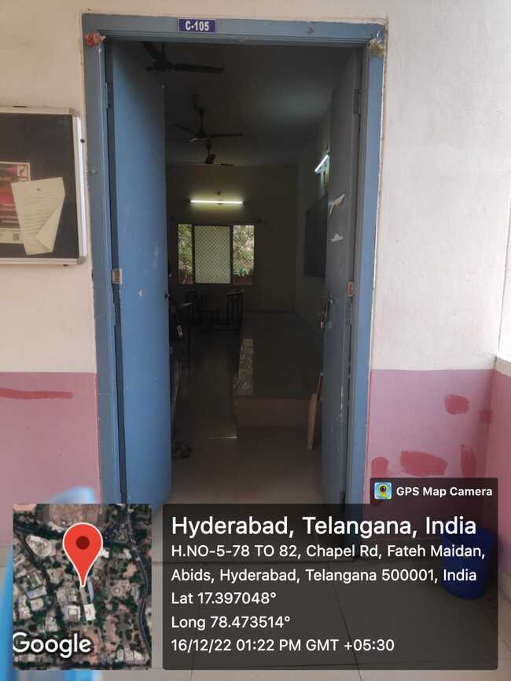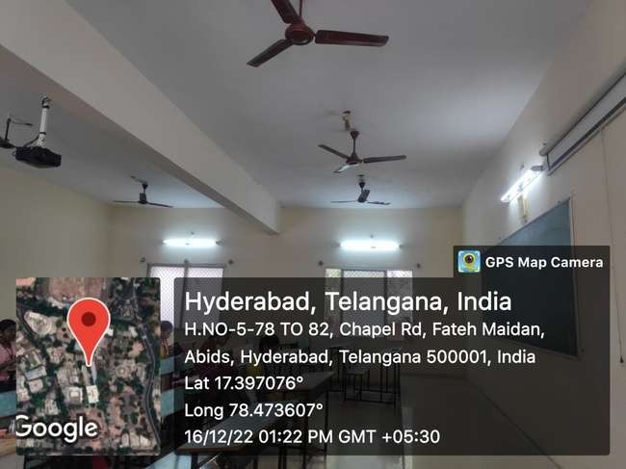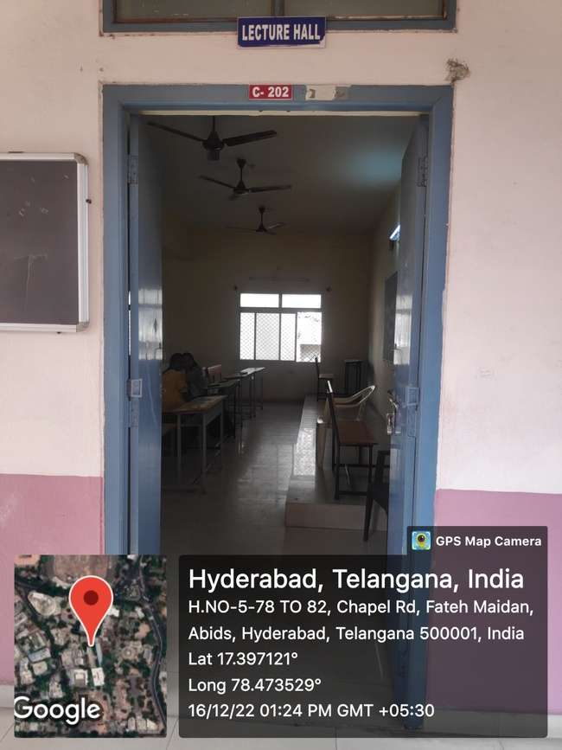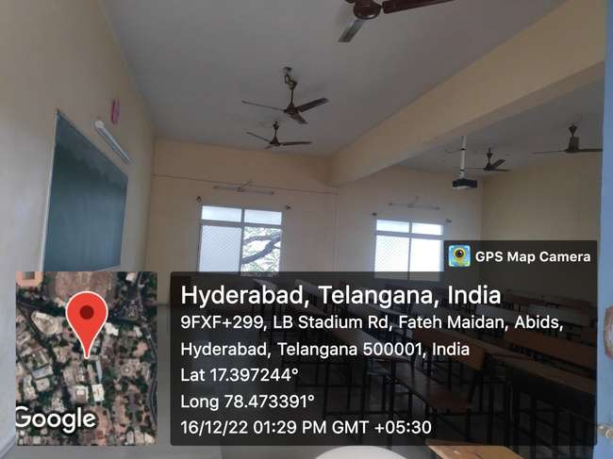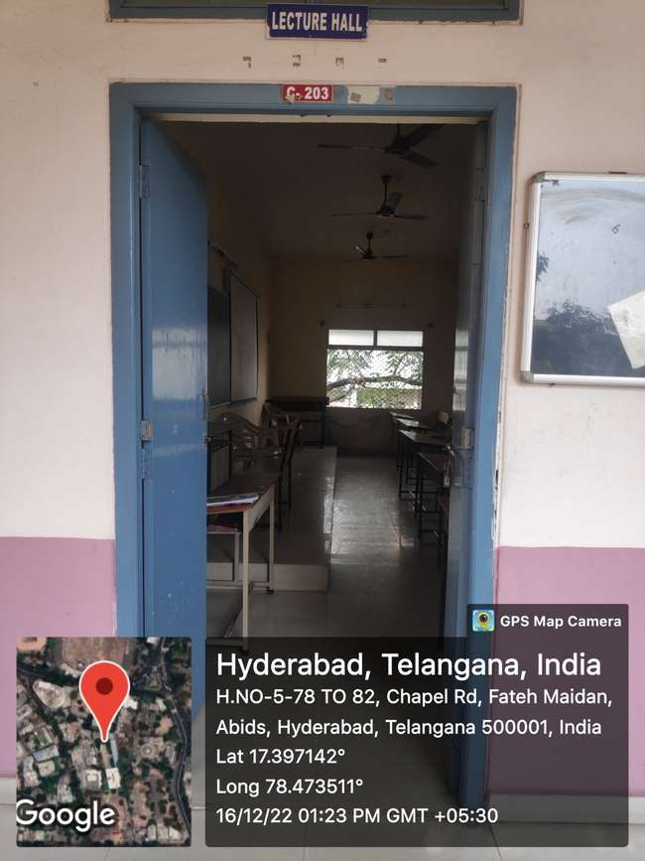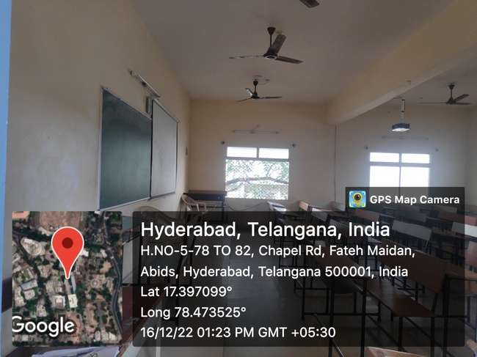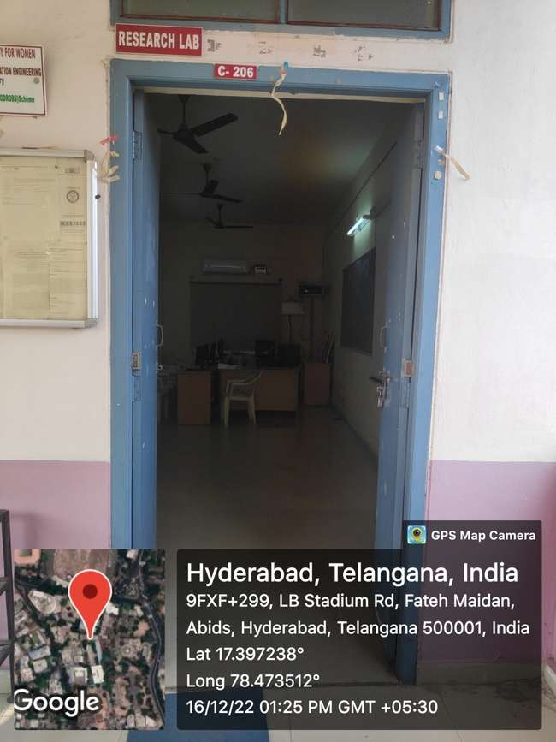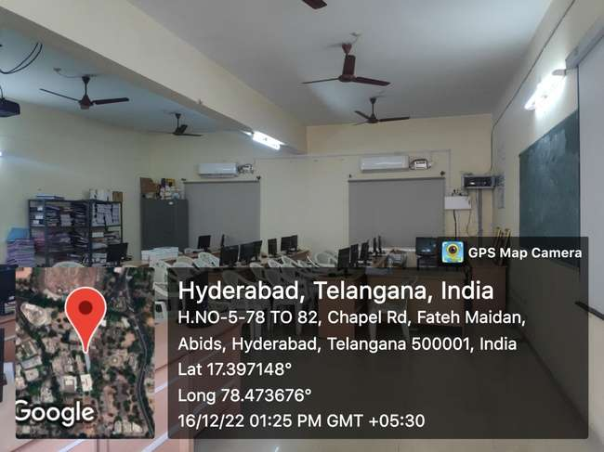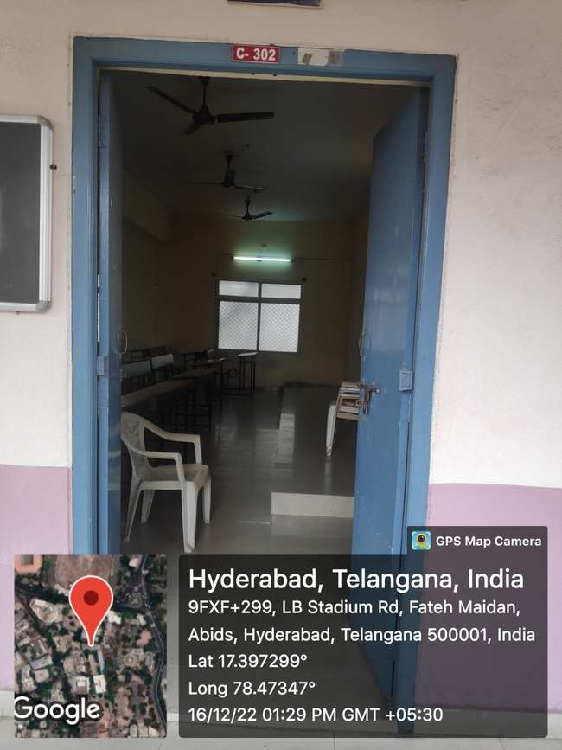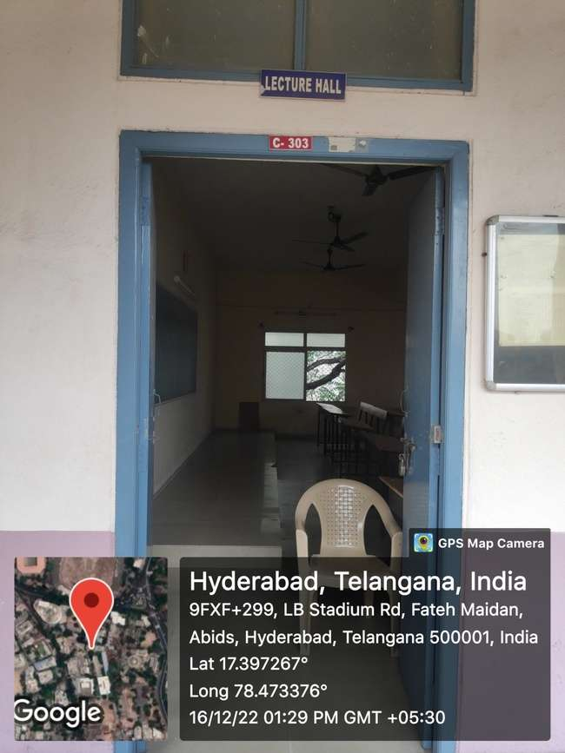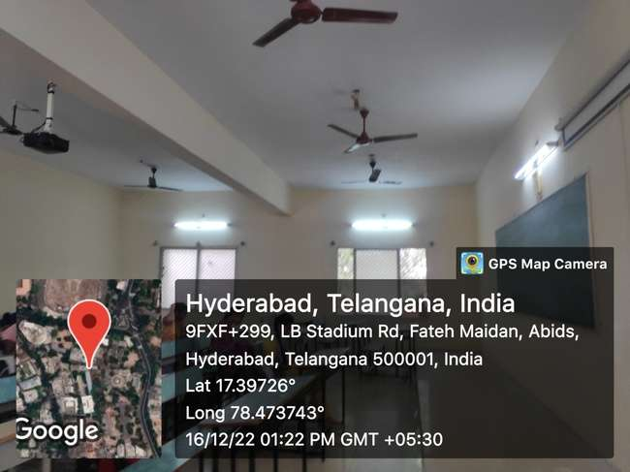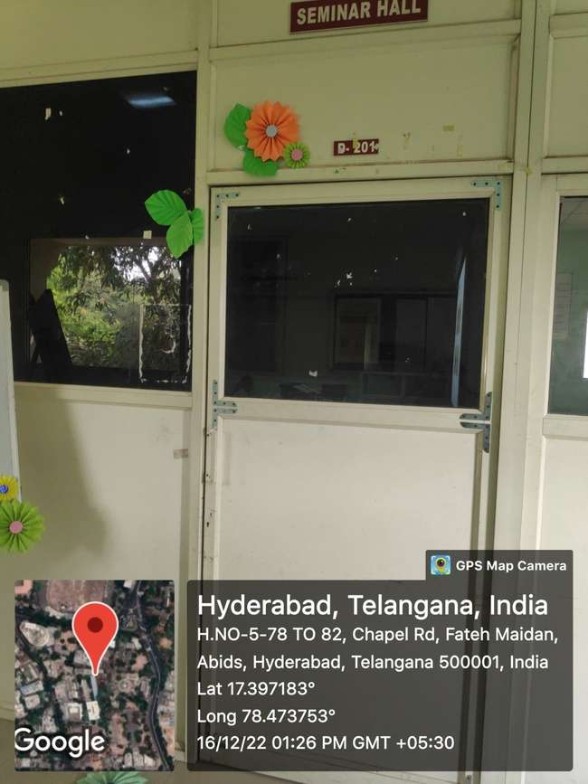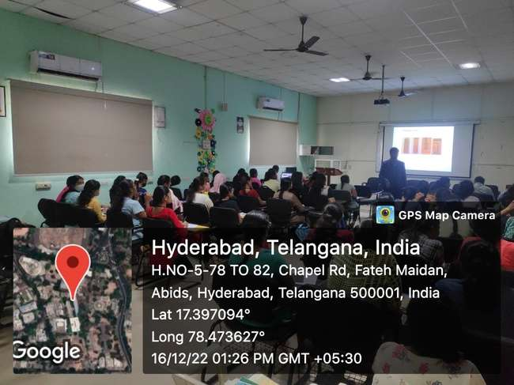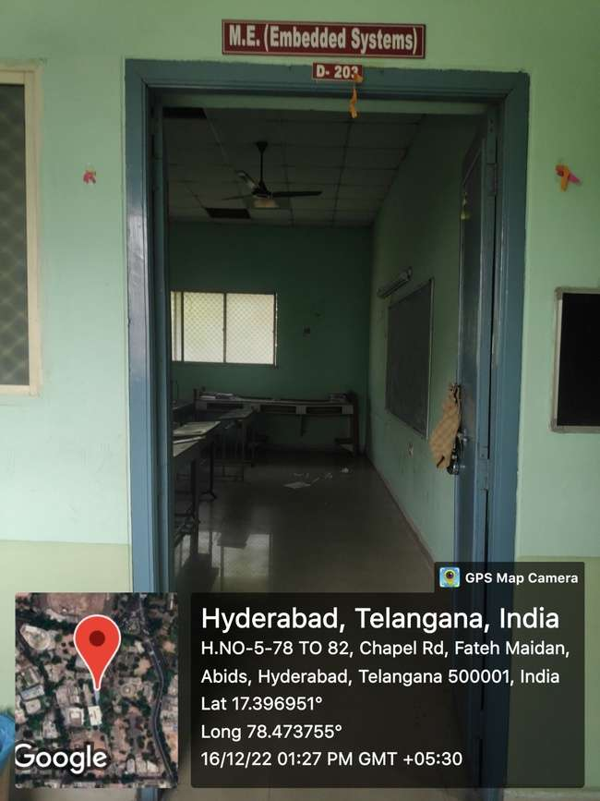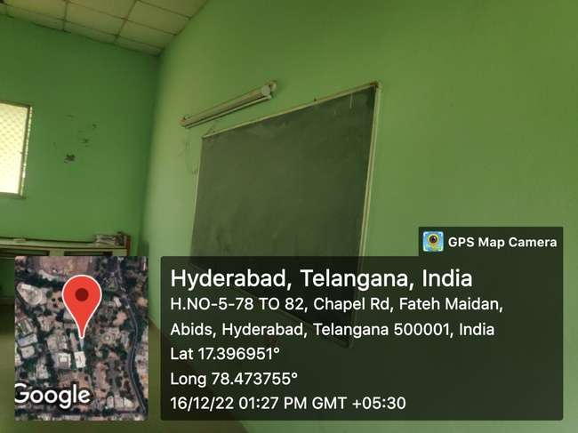

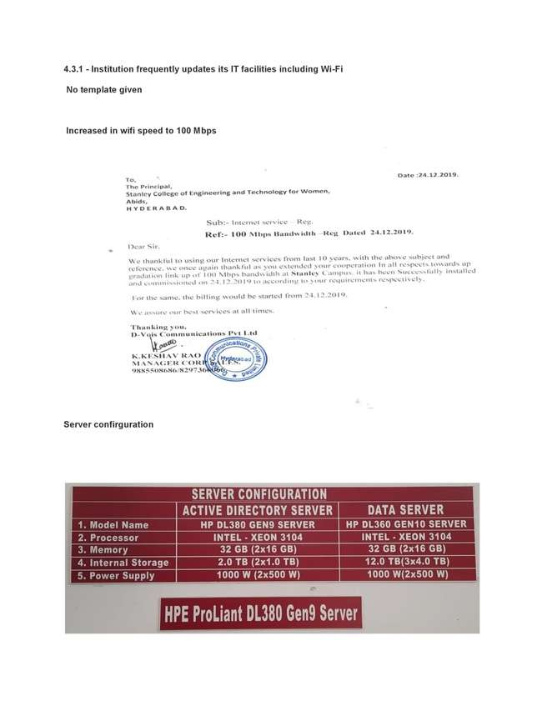

4.3.1 – Technology Upgradation (overall)
Type | Total Computers | Computer Lab | Internet | Browsing centers | Computer Centers | Departments | Available Bandwidth (MBPS/GBPS)
Existing | 64 | LAB 1&2 E-BLOCK | 30 MBPS Pioneer Leased line,100mbs VOIS COMMUNICATION LEASED LINE | Lab-1&2 | Lab 1 & 2 | CME | 100mbs VOIS COMMUNICATION LEASED LINE 30mbs PIONEER LEASED LINE

