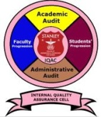
Stanley College of Engineering and Technology for Women
(Autonomous)
(Affiliated to Osmania University)
(Accredited by NAAC with”A” Grade, Accredited by NBA)
Chapel Road, Abids, Hyderabad – 500 001

INTERNAL QUALITY ASSURANCE CELL (IQAC)
Format: IQAC -

Report on Participation in Cultural Activities

Session: | 2021 - 22
Semester: | Even/Odd
Cultural Activity: | Traditional Day
Name of Event: | Traditional Day
Date: | 16-4-2022
Time: | 09:00AM to 04:30PM
Location: | Stanley College of Engineering and Technology for Women

Student Details:
Branch | Total Count
AIDS  CME  CSE  ECE  EEE  IT  MBA/M E/ M Tech | 1350

Activity Objectives | To Create inclusive environment by conducting different cultural events.
Activity Outcomes | Harmony among student fraternity and teaching fraternity.

Ms B N S M Chandrika
Co-Ordinator

Photos

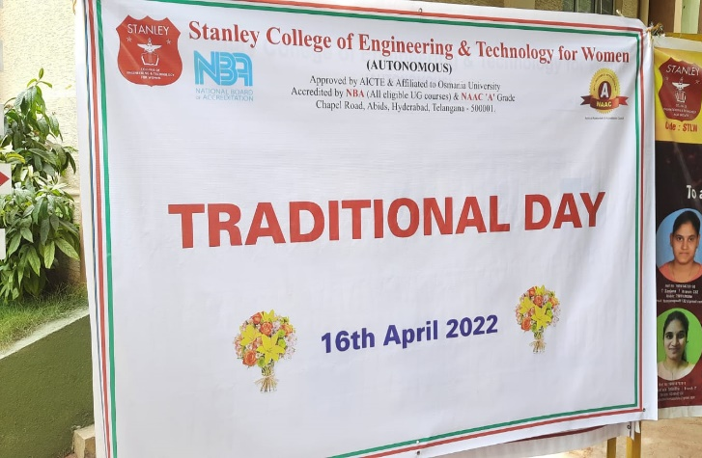 | 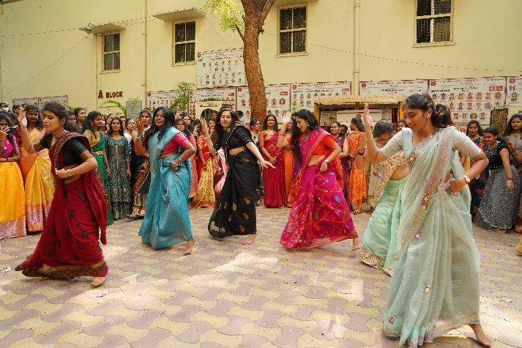
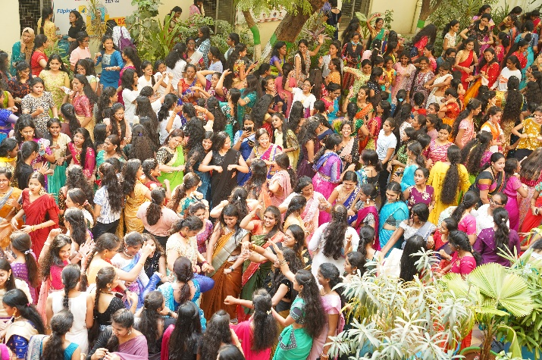 | 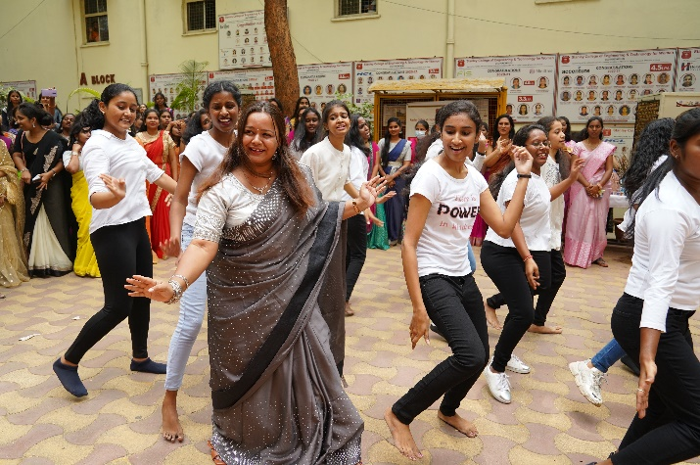
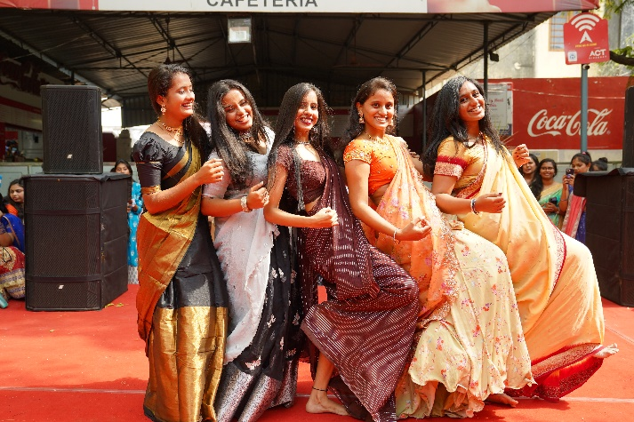 | 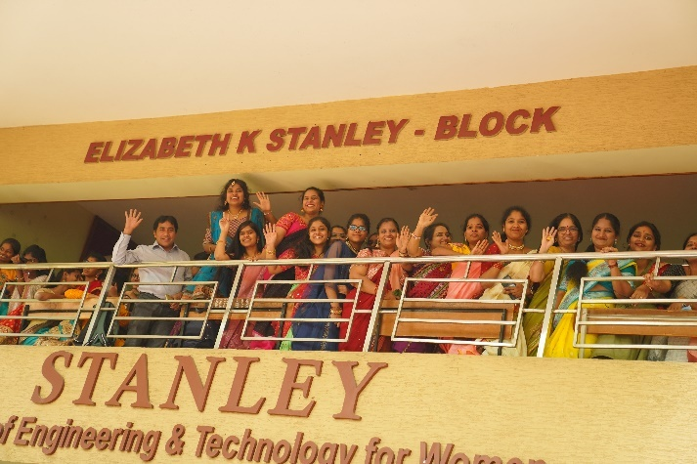
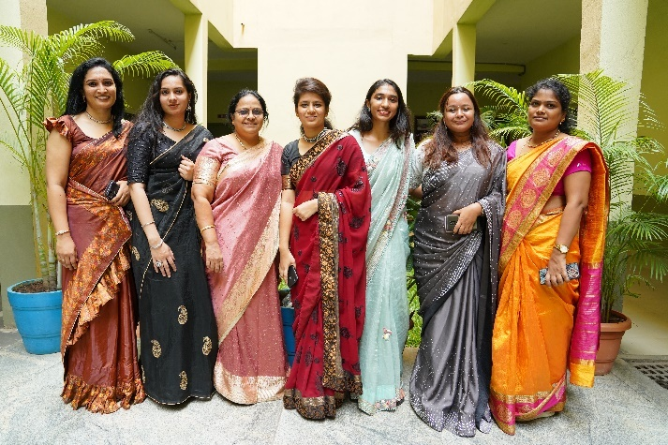 | 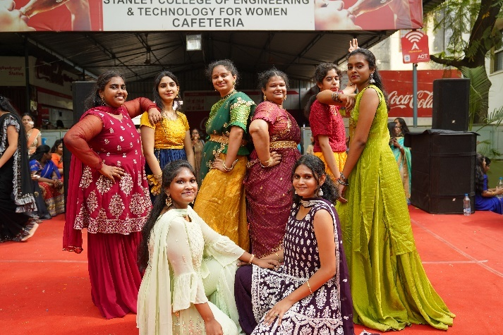
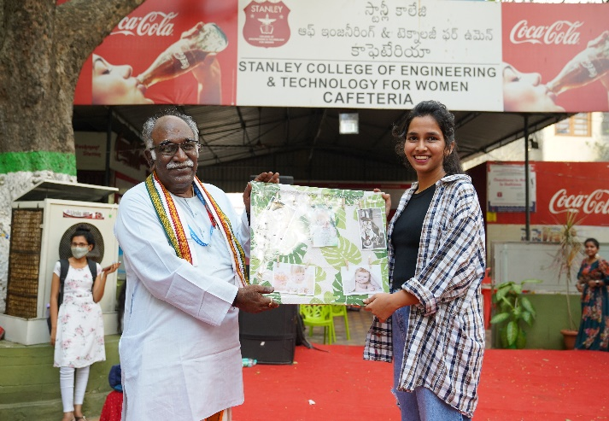 | 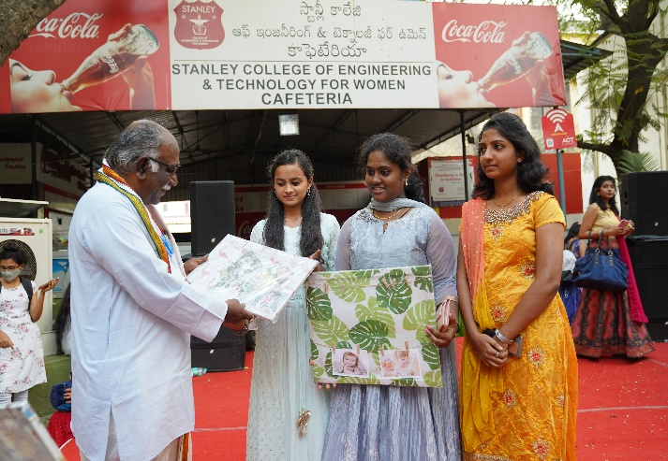

Ms B N S M Chandrika
Co-Ordinator

