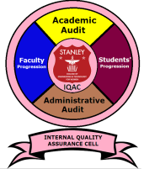
STANLEY COLLEGE OF ENGINEERING AND TECHNOLOGY FOR WOMEN
(Affiliated to Osmania University)
(Accredited by NAAC with “A” Grade, Accredited by NBA)
ABIDS, HYDERABAD- 500 001

INTERNAL QUALITY ASSURANCE CELL (IQAC)

Strategies

IQAC shall evolve a mechanism and procedures for

- Ensuring timely, efficient and progressive performance of academic, administrative and financial units;
- Adoption of relevant and quality academic and research programmes;
- Ensuring equitable access to and affordability of academic programmes for various sections of the society;
- Optimization and integration of modern methods of teaching and learning;
- Ensuring credible assessment and evaluation processes;
- Ensuring the proper allocation, adequacy and maintenance of support structure and services; and
- Sharing of research findings and networking with other institutions in India and abroad.

