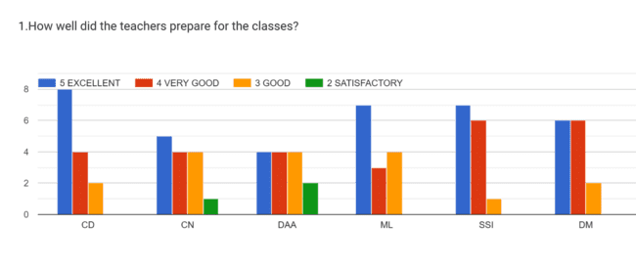

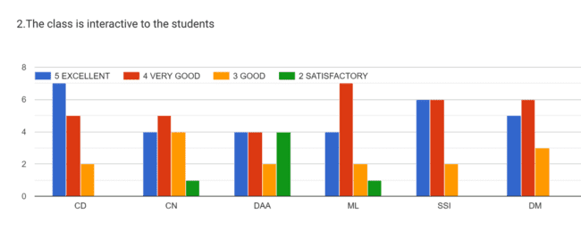
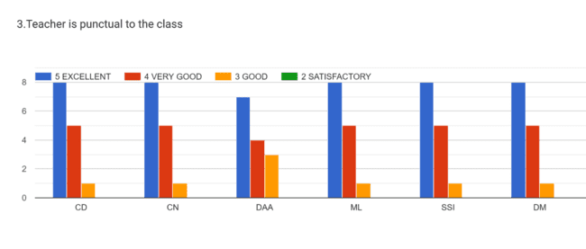
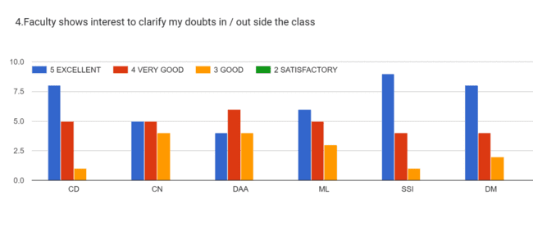
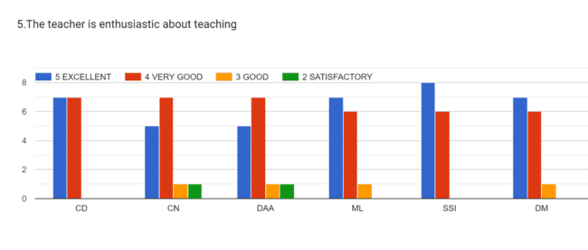

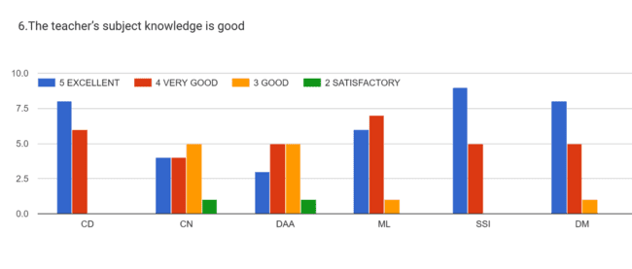
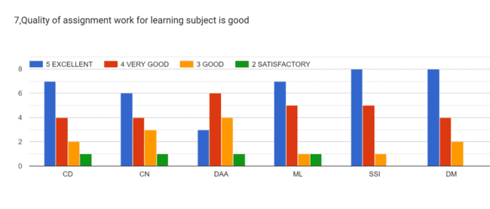
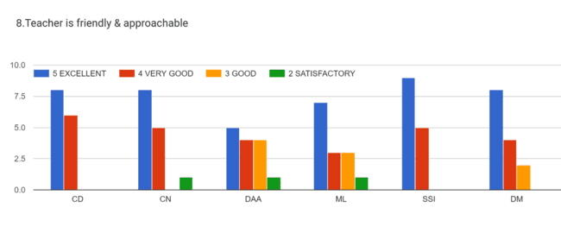
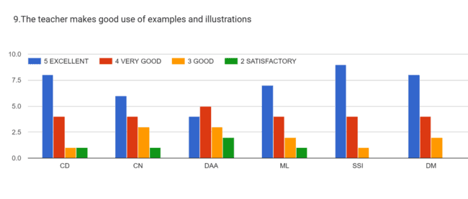
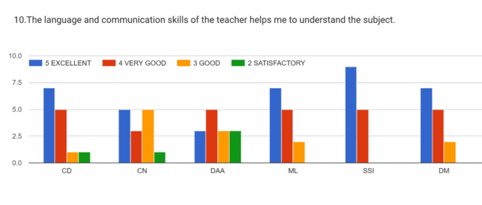
VIII SEM
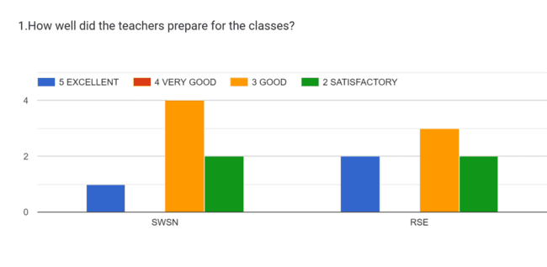

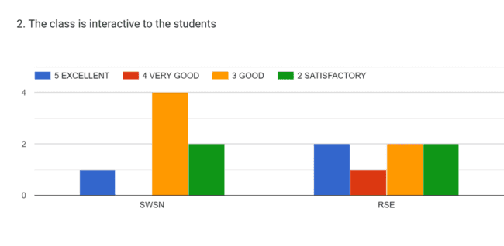
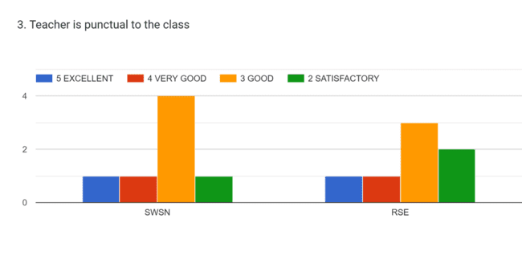
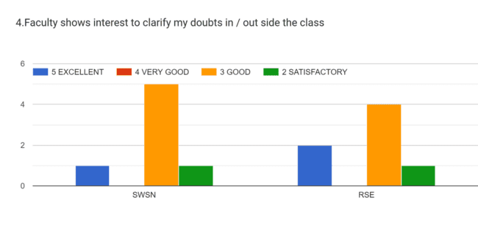
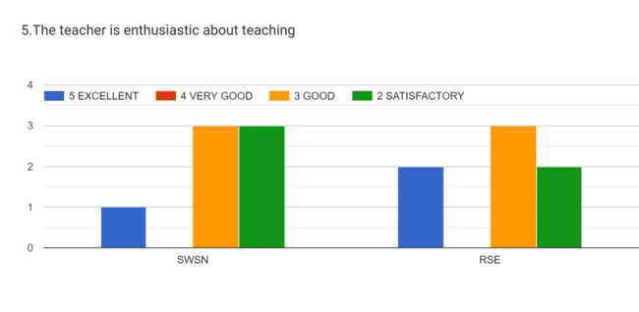
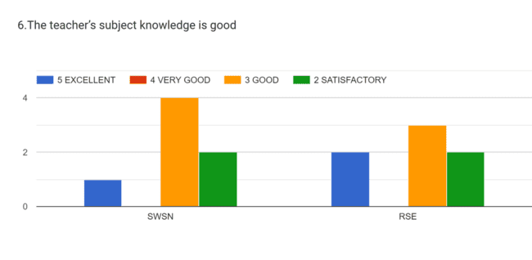
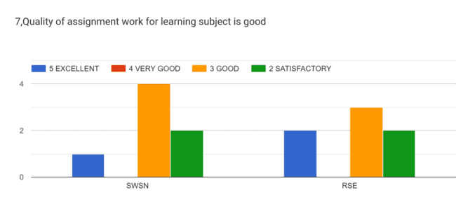
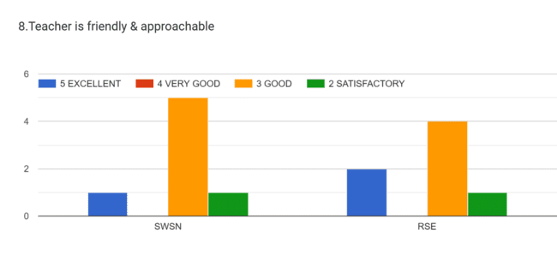
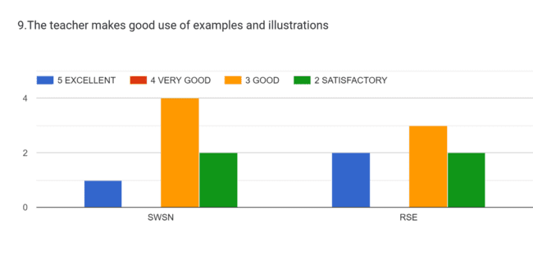
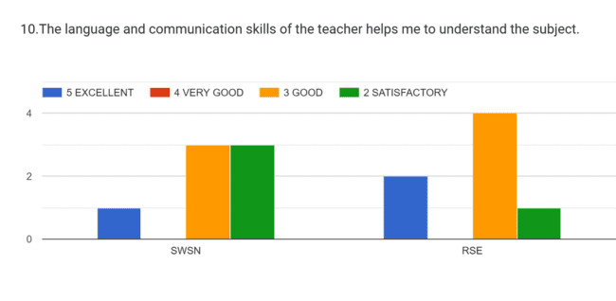
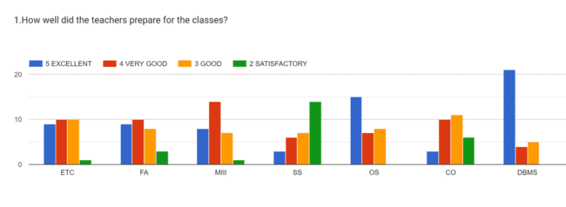
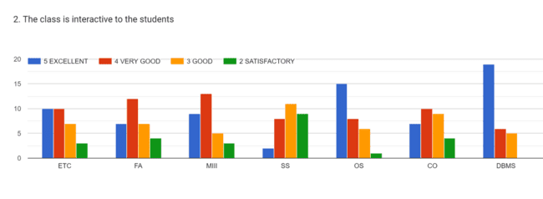
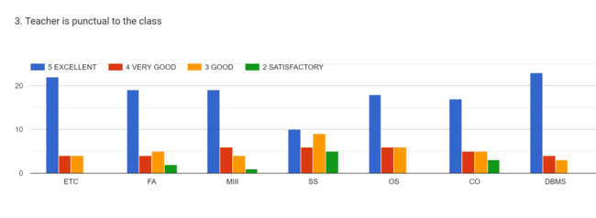
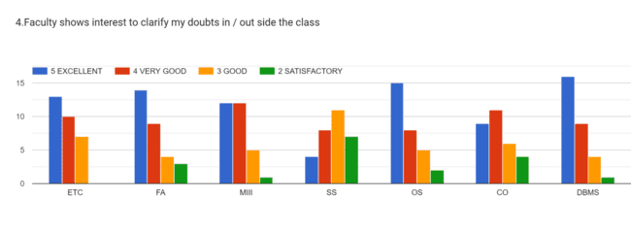
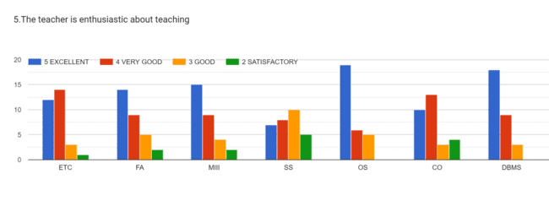
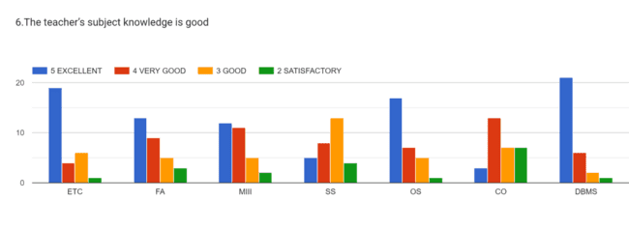
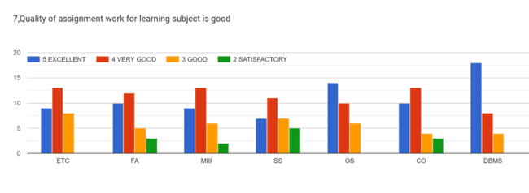
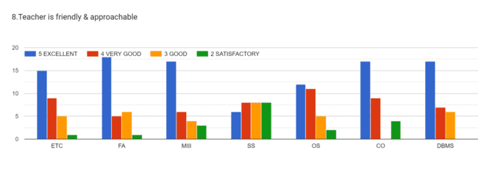
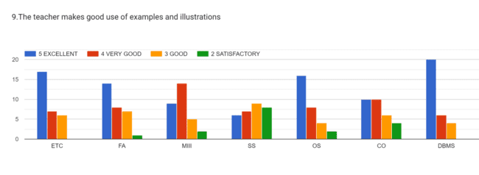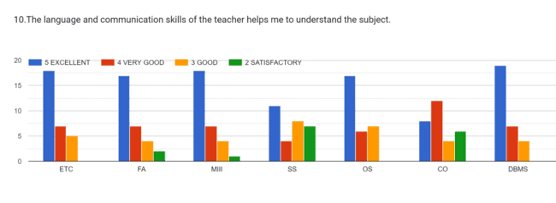

2.7.1 Student Satisfaction Survey

1. How much of the syllabus was covered in the class?

2. How well did the teachers prepare for the classes?

3. How well were the teachers able to communicate?

4. The teacher’s approach to teaching can best be described as

5. Fairness of the internal evaluation process by the teacher

6. Was your performance in assignments discussed with you?

7. The institute takes active interest in promoting internship, student exchange, field visit opportunities for students.

8. The teaching and mentoring process in the institution facilitates you in cognitive, social and emotional growth.

9. The institution provides multiple opportunities to learn and grow.
10. The institution provides multiple opportunities to learn and grow.

11. Your mentor does a necessary follow-up with an assigned task to you.

12. Your mentor does a necessary follow-up with an assigned task to you.

13. The teachers identify your strengths and encourage you with providing right level of challenges

14. Teachers are able to identify your weaknesses and help you to overcome them.

15. The institution makes effort to engage students in the monitoring, review and continuous quality improvement ofthe teaching learning process.

16. The institute/ teachers use student centric methods, such as experiential learning, participative learning and problem solving methodologies for enhancing learning experiences

17. Teachers encourage you to participate in extracurricular activities

18. Efforts are made by the institute/ teachers to inculcate soft skills, life skills and employ ability skills to make you ready for the world of work.

19. What percentage of teachers use ICT tools such as LCD projector, Multimedia, etc. while teaching.

20. What percentage of teachers use ICT tools such as LCD projector, Multimedia, etc. while teaching.

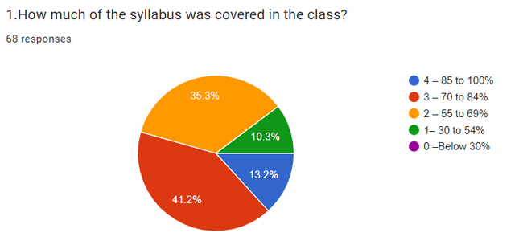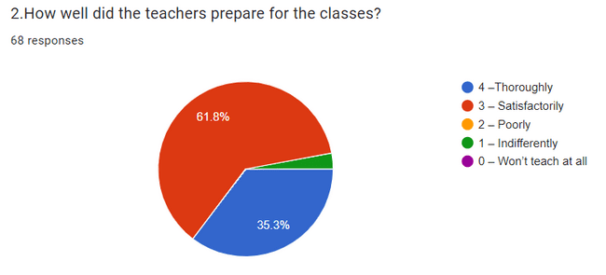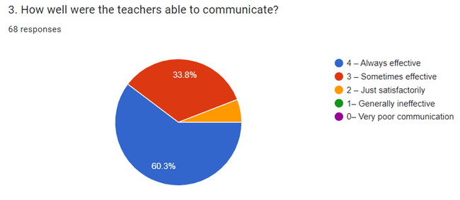
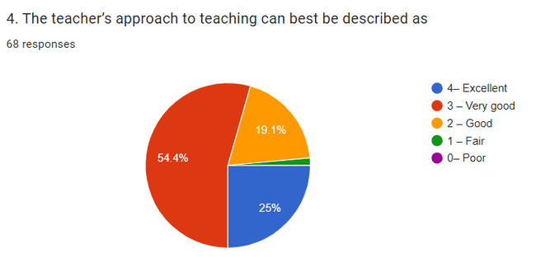

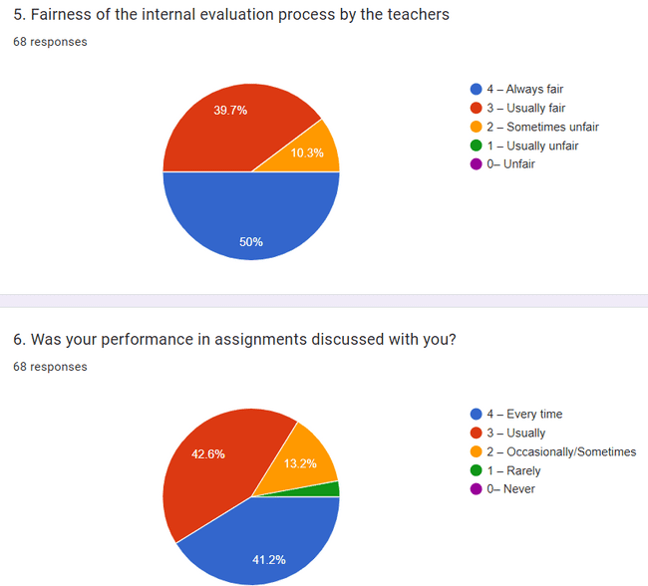

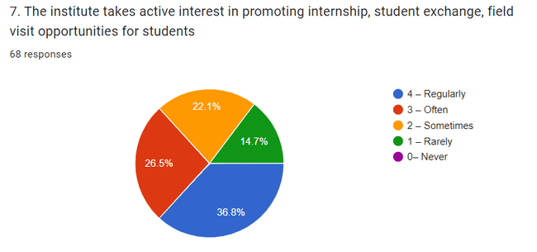
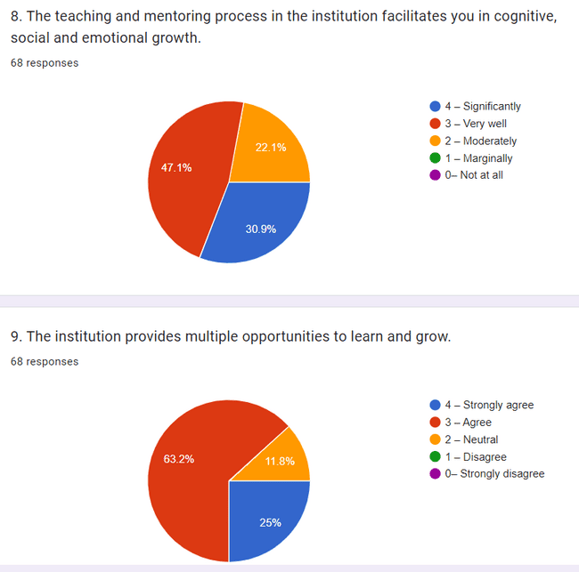
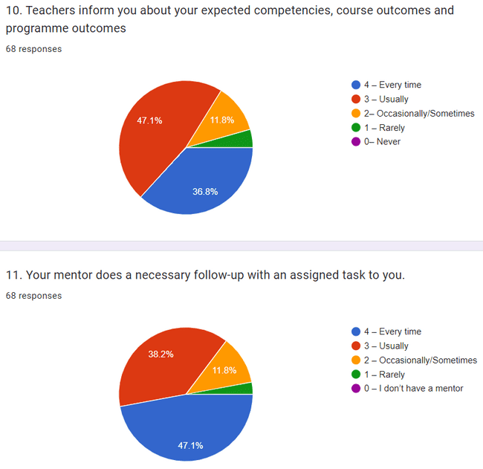
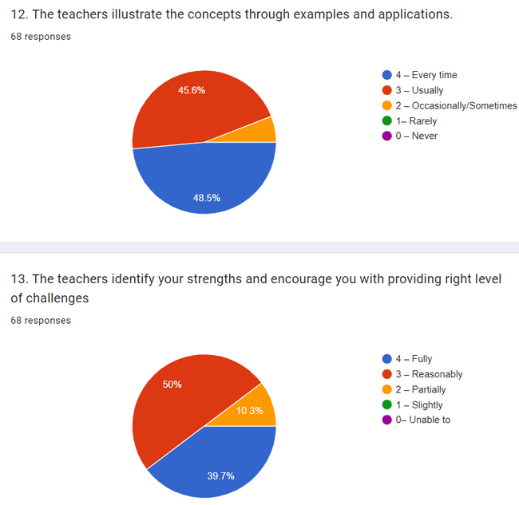
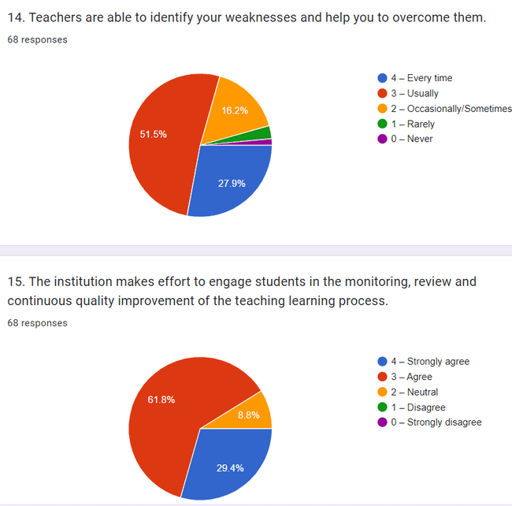

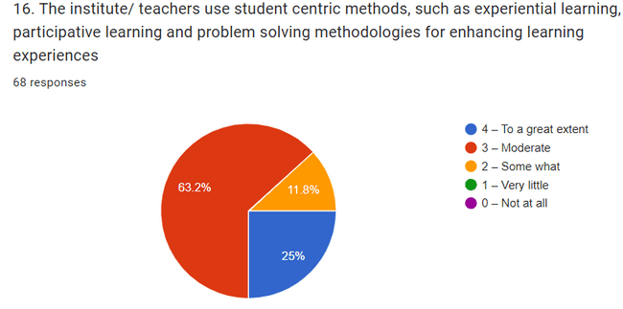
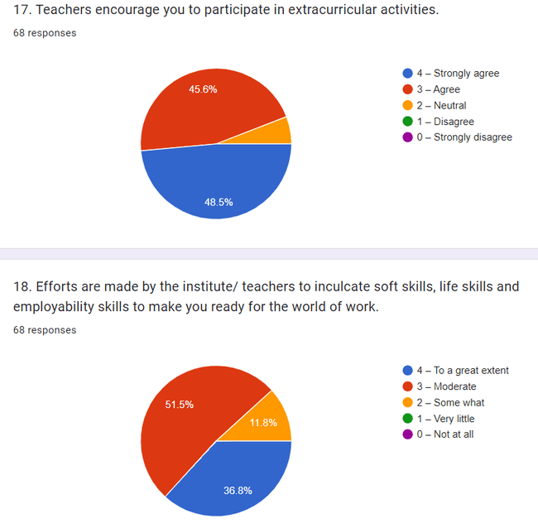
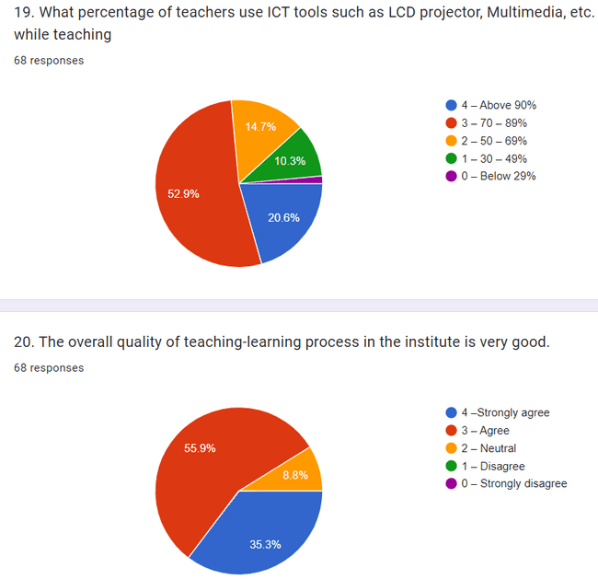

1.How much of the syllabus was covered in the class? [AI(Dr. Srinivasu)]
No of response:105
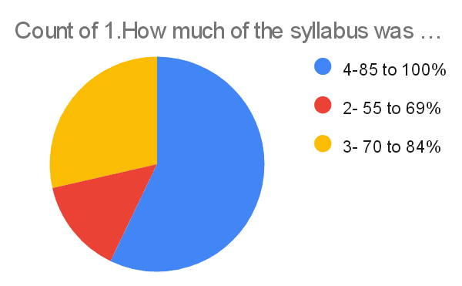

1.How much of the syllabus was covered in the class? [AT(Mrs. Afreen Fatima Mohammed)]
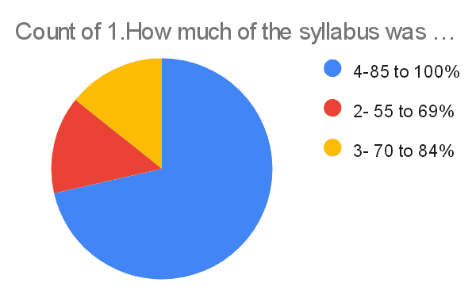

1.How much of the syllabus was covered in the class? [OS(Ms. Sumedha & Dr. Rama KRISHNA)]
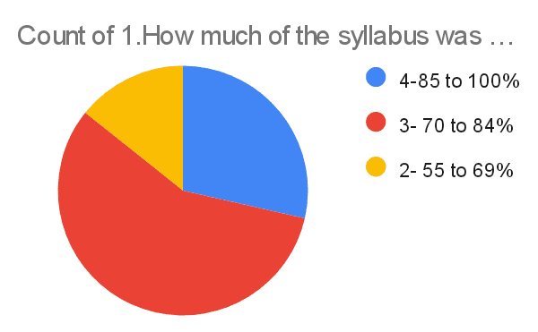

1.How much of the syllabus was covered in the class? [WAD(Mrs. CH. Shruthi)]

1.How much of the syllabus was covered in the class? [CN( Mrs. Nagmani)]

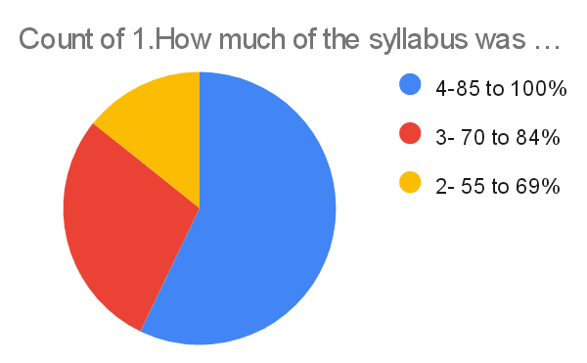

1.How much of the syllabus was covered in the class? [SE(Mr. Shiva Krishna)]

2.How well did the teachers prepare for the classes? [AI(Dr. Srinivasu)]

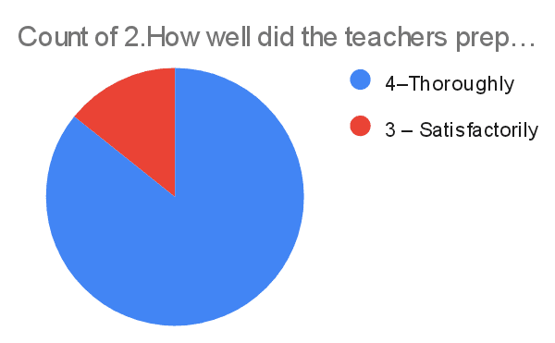

2.How well did the teachers prepare for the classes? [AT(Mrs. Afreen Fatima Mohammed)]

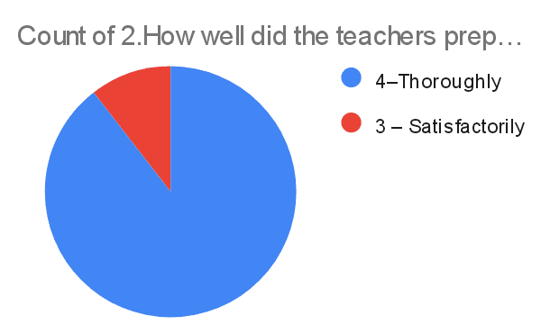

2.How well did the teachers prepare for the classes? [SE(Mr. Shiva Krishna)]

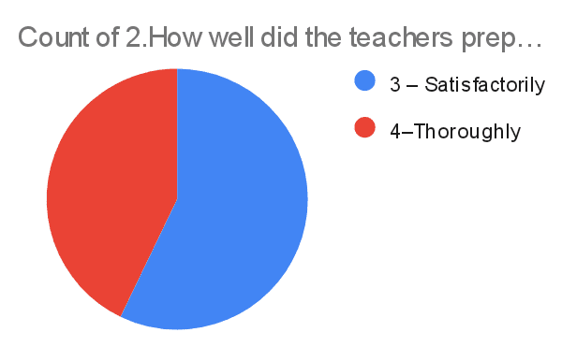
2.How well did the teachers prepare for the classes? [CN( Mrs. Nagmani)]
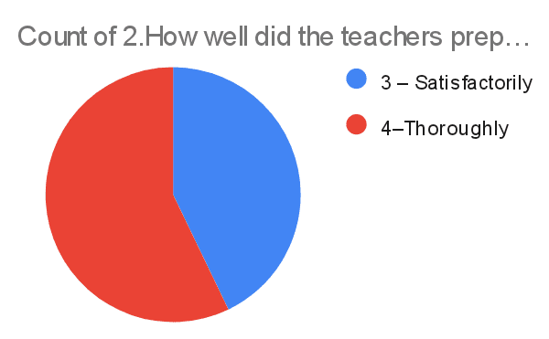

2.How well did the teachers prepare for the classes? [WAD(Mrs. CH. Shruthi)]
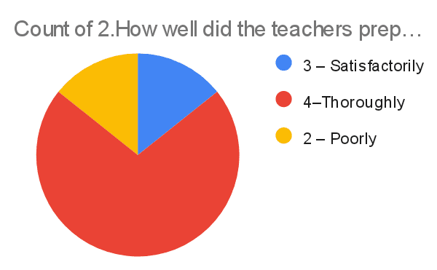
3. How well were the teachers able to communicate? [AI(Dr. Srinivasu)]
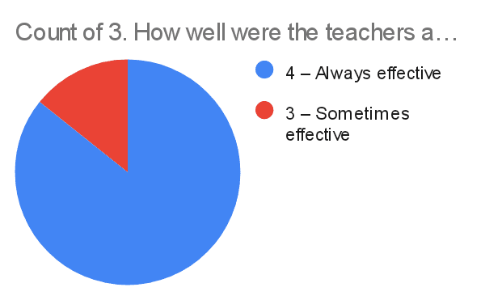
3. How well were the teachers able to communicate? [AT(Mrs. Afreen Fatima Mohammed)]
3. How well were the teachers able to communicate? [OS(Ms. Sumedha & Dr. Rama KRISHNA)]
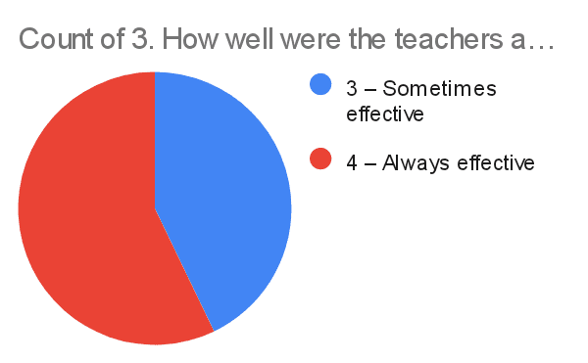

3. How well were the teachers able to communicate? [WAD(Mrs. CH. Shruthi)]
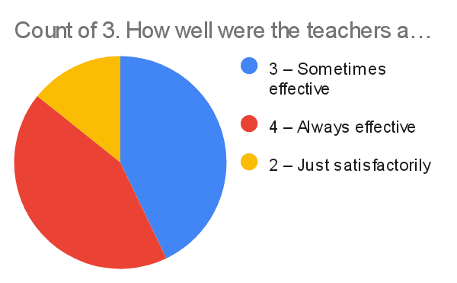
4. The teacher’s approach to teaching can best be described as [AI(Dr. Srinivasu)]
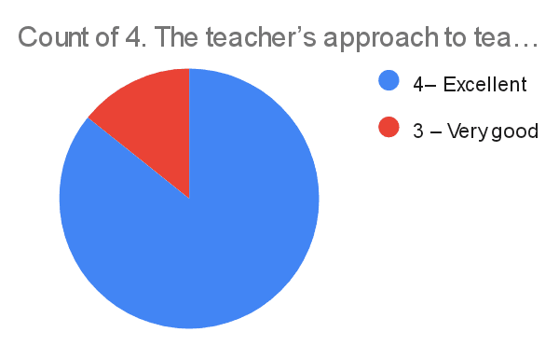

4. The teacher’s approach to teaching can best be described as [AT(Mrs. Afreen Fatima Mohammed)]
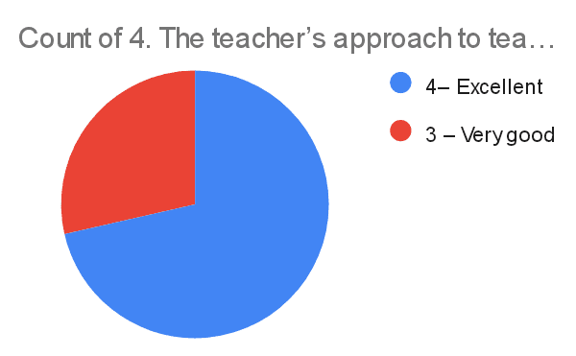
4. The teacher’s approach to teaching can best be described as [OS(Ms. Sumedha & Dr. Rama KRISHNA)]
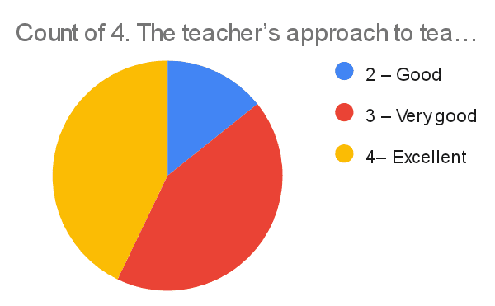
4. The teacher’s approach to teaching can best be described as [WAD(Mrs. CH. Shruthi)]
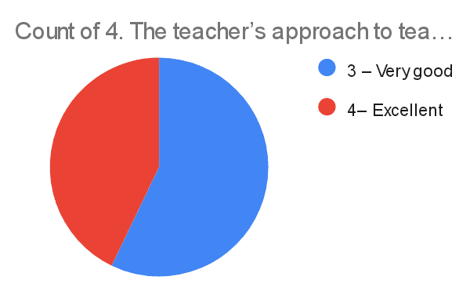

4. The teacher’s approach to teaching can best be described as [CN( Mrs. Nagmani)]
4. The teacher’s approach to teaching can best be described as [SE(Mr. Shiva Krishna)]
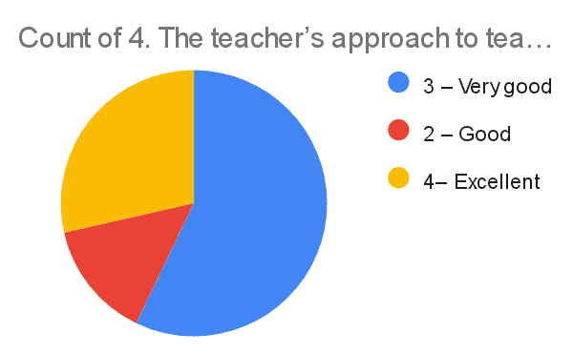

5. Fairness of the internal evaluation process by the teachers.
[AI(Dr. Srinivasu)]
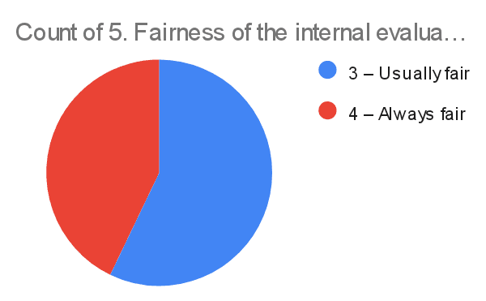
5. Fairness of the internal evaluation process by the teachers.
[AT(Mrs. Afreen Fatima Mohammed)]

5. Fairness of the internal evaluation process by the teachers.
[OS(Ms. Sumedha & Dr. Rama KRISHNA)]
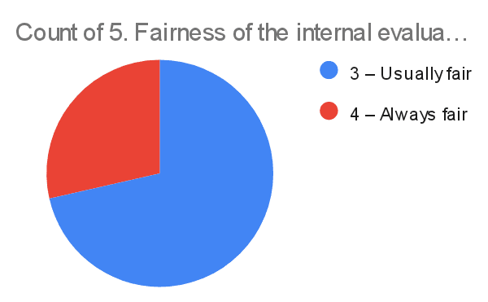
5. Fairness of the internal evaluation process by the teachers.
[WAD(Mrs. CH. Shruthi)]

5. Fairness of the internal evaluation process by the teachers.
[CN( Mrs. Nagmani)]
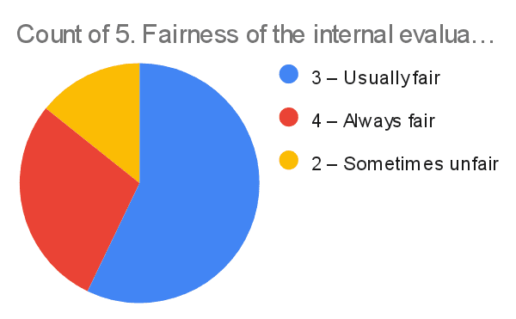
5. Fairness of the internal evaluation process by the teachers.
[SE(Mr. Shiva Krishna)]

6. Was your performance in assignments discussed with you? [AI(Dr. Srinivasu)]
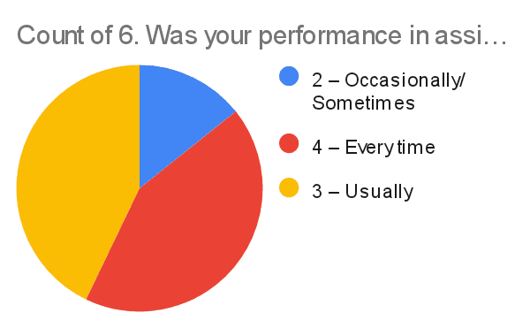
6. Was your performance in assignments discussed with you? [AT(Mrs. Afreen Fatima Mohammed)]

6. Was your performance in assignments discussed with you? [OS(Ms. Sumedha & Dr. Rama KRISHNA) ]
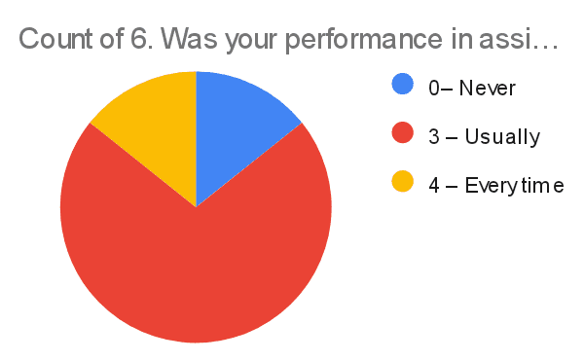
6. Was your performance in assignments discussed with you? [WAD(Mrs. CH. Shruthi)]

6. Was your performance in assignments discussed with you? [CN( Mrs. Nagmani)]
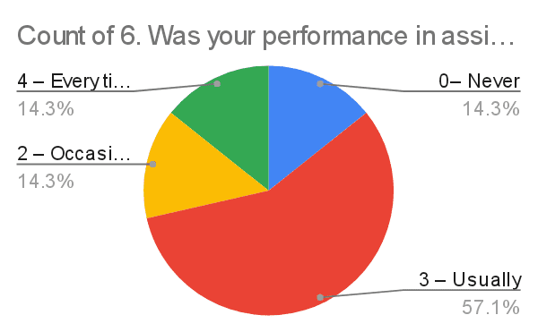
6. Was your performance in assignments discussed with you? [SE(Mr. Shiva Krishna)]
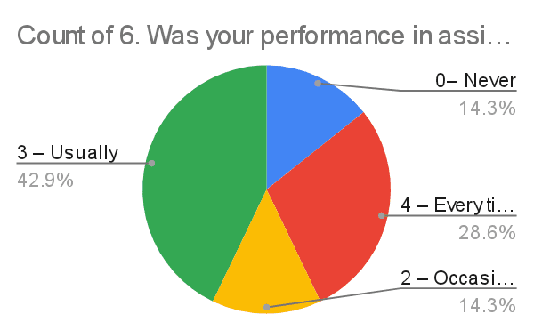
7. The institute takes active interest in promoting internship, student exchange, field visit opportunities for students. [AI(Dr. Srinivasu)]
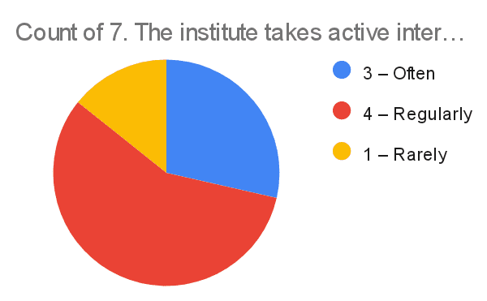
7. The institute takes active interest in promoting internship, student exchange, field visit opportunities for students. [AT(Mrs. Afreen Fatima Mohammed)]
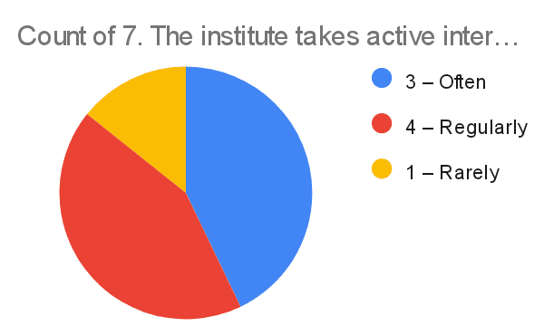
7. The institute takes active interest in promoting internship, student exchange, field visit opportunities for students. [OS(Ms. Sumedha & Dr. Rama KRISHNA)]
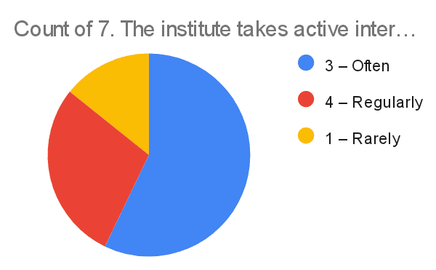
7. The institute takes active interest in promoting internship, student exchange, field visit opportunities for students. [WAD(Mrs. CH. Shruthi)]

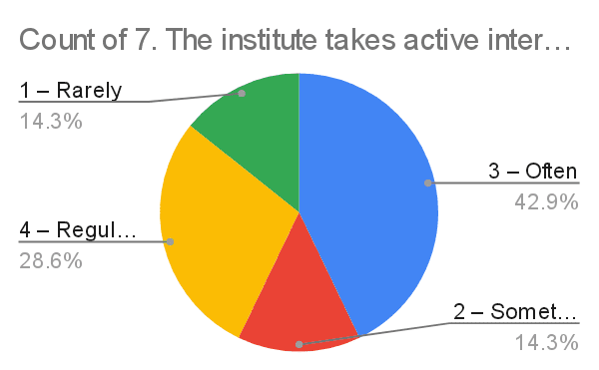

7. The institute takes active interest in promoting internship, student exchange, field visit opportunities for students. [CN( Mrs. Nagmani)]
7. The institute takes active interest in promoting internship, student exchange, field visit opportunities for students. [SE(Mr. Shiva Krishna)]

8.The teaching and mentoring process in the institution facilitates you in cognitive, social and emotional growth. [AI(Dr. Srinivasu)]
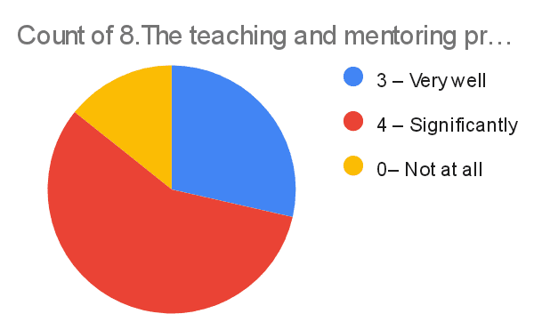
8.The teaching and mentoring process in the institution facilitates you in cognitive, social and emotional growth. [AT(Mrs. Afreen Fatima Mohammed)]

8.The teaching and mentoring process in the institution facilitates you in cognitive, social and emotional growth. [OS(Ms. Sumedha & Dr. Rama KRISHNA)]
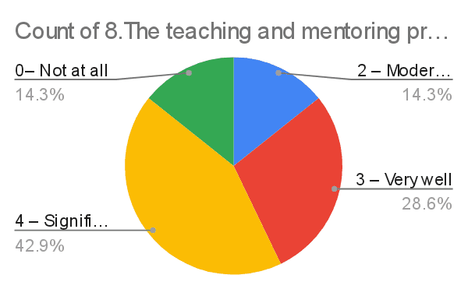
8.The teaching and mentoring process in the institution facilitates you in cognitive, social and emotional growth. [WAD(Mrs. CH. Shruthi)]
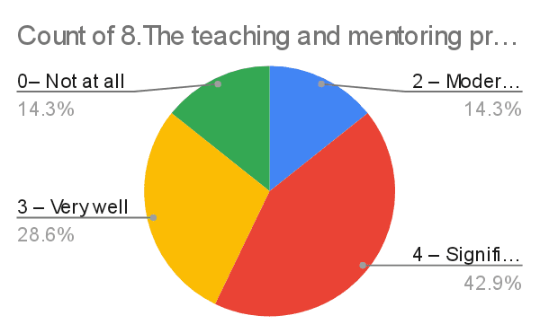

8.The teaching and mentoring process in the institution facilitates you in cognitive, social and emotional growth. [CN( Mrs. Nagmani)]
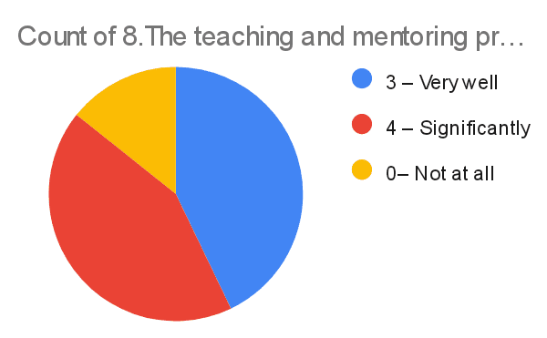
8.The teaching and mentoring process in the institution facilitates you in cognitive, social and emotional growth. [SE(Mr. Shiva Krishna)]
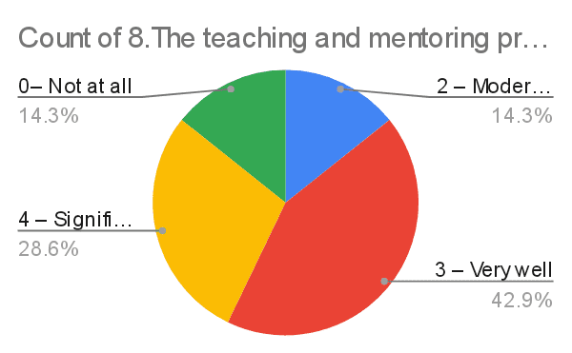

9. The institution provides multiple opportunities to learn and grow.* [AI(Dr. Srinivasu)]
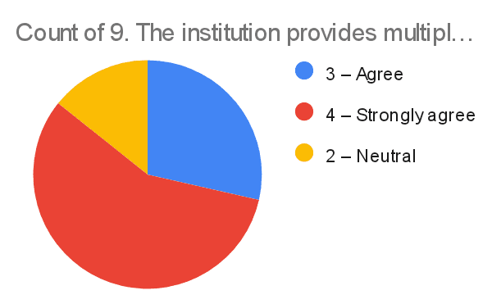

9. The institution provides multiple opportunities to learn and grow.* [AT(Mrs. Afreen Fatima Mohammed)]

9. The institution provides multiple opportunities to learn and grow.* [OS(Ms. Sumedha & Dr. Rama KRISHNA)]
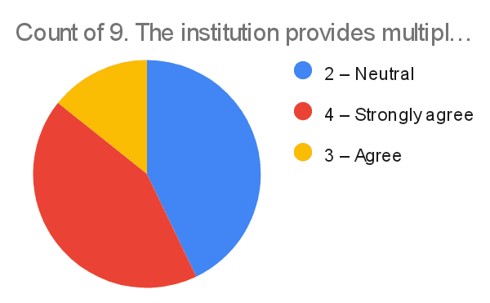

9. The institution provides multiple opportunities to learn and grow.* [WAD(Mrs. CH. Shruthi)]

9. The institution provides multiple opportunities to learn and grow.* [CN( Mrs. Nagmani)]
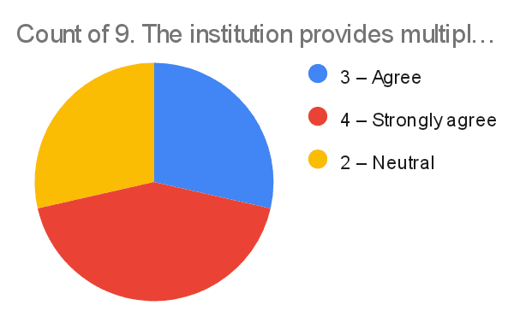

9. The institution provides multiple opportunities to learn and grow.* [SE(Mr. Shiva Krishna)]

10. Teachers inform you about your expected competencies, course outcomes and programme outcomes. [AI(Dr. Srinivasu)]
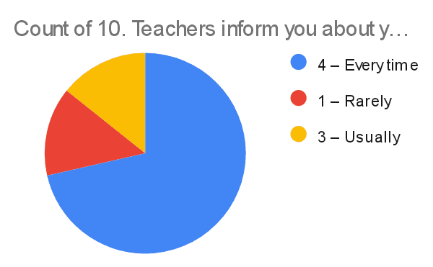
10. Teachers inform you about your expected competencies, course outcomes and programme outcomes. [AT(Mrs. Afreen Fatima Mohammed)]

10. Teachers inform you about your expected competencies, course outcomes and programme outcomes. [OS(Ms. Sumedha & Dr. Rama KRISHNA)]
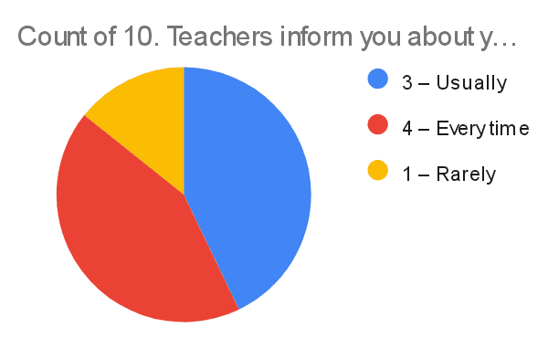
10. Teachers inform you about your expected competencies, course outcomes and programme outcomes. [WAD(Mrs. CH. Shruthi)]
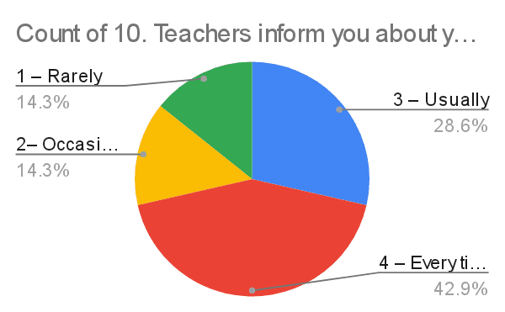

10. Teachers inform you about your expected competencies, course outcomes and programme outcomes. [CN( Mrs. Nagmani)]
10. Teachers inform you about your expected competencies, course outcomes and programme outcomes. [SE(Mr. Shiva Krishna)]
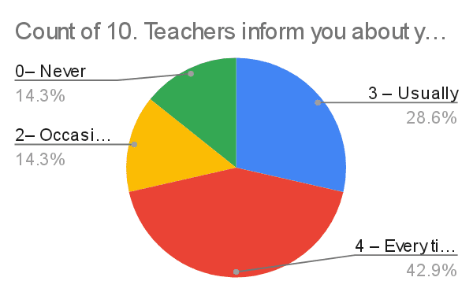

11. Your mentor does a necessary follow-up with an assigned task to you. [AI(Dr. Srinivasu)]
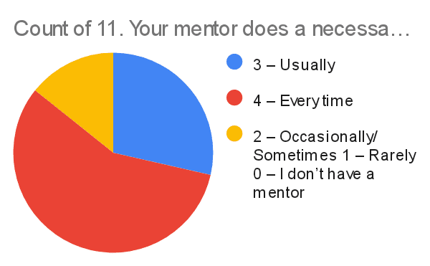
11. Your mentor does a necessary follow-up with an assigned task to you. [AT(Mrs. Afreen Fatima Mohammed)]

11. Your mentor does a necessary follow-up with an assigned task to you. [OS(Ms. Sumedha & Dr. Rama KRISHNA)]
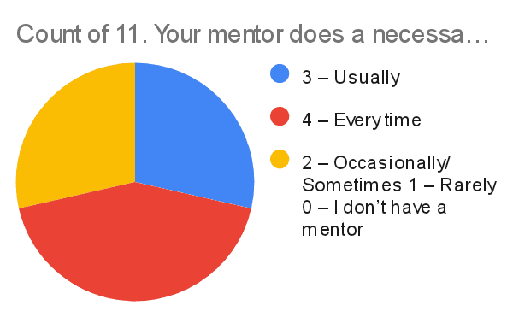
11. Your mentor does a necessary follow-up with an assigned task to you. [WAD(Mrs. CH. Shruthi)]

11. Your mentor does a necessary follow-up with an assigned task to you. [CN( Mrs. Nagmani)]
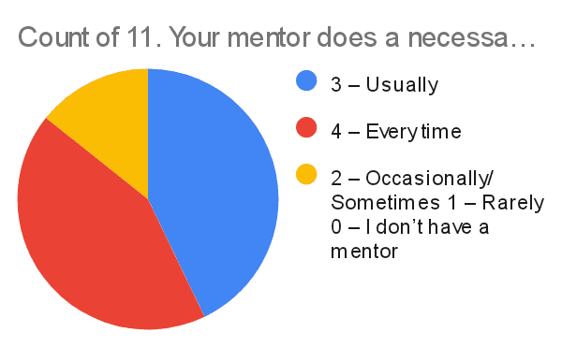
11. Your mentor does a necessary follow-up with an assigned task to you. [SE(Mr. Shiva Krishna)]

12. The teachers illustrate the concepts through examples and applications [AI(Dr. Srinivasu)]
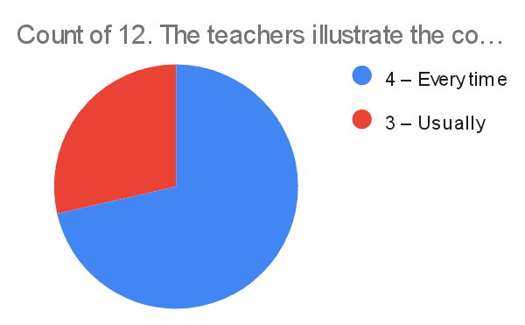

12. The teachers illustrate the concepts through examples and applications [AT(Mrs. Afreen Fatima Mohammed)]

12. The teachers illustrate the concepts through examples and applications [OS(Ms. Sumedha & Dr. Rama KRISHNA)]
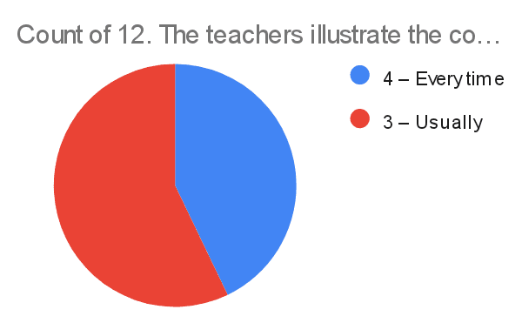

12. The teachers illustrate the concepts through examples and applications [WAD(Mrs. CH. Shruthi)]
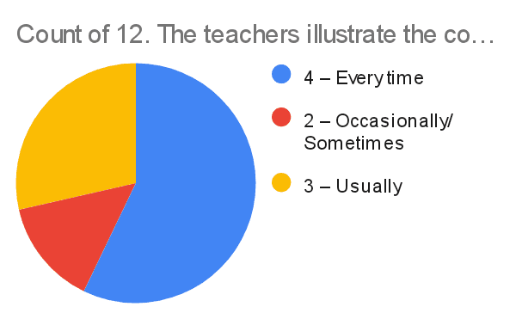

12. The teachers illustrate the concepts through examples and applications [CN( Mrs. Nagmani)]

12. The teachers illustrate the concepts through examples and applications [SE(Mr. Shiva Krishna)]
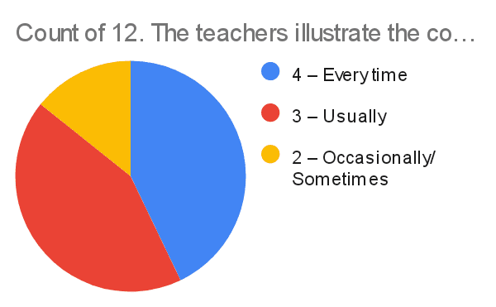

13. The teachers identify your strengths and encourage you with providing right level of challenges. [AI(Dr. Srinivasu)]
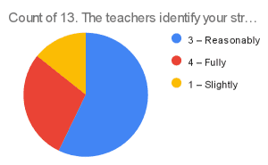
13. The teachers identify your strengths and encourage you with providing right level of challenges. [AT(Mrs. Afreen Fatima Mohammed)]
13. The teachers identify your strengths and encourage you with providing right level of challenges. [OS(Ms. Sumedha & Dr. Rama KRISHNA)]
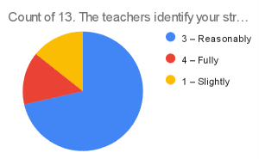
13. The teachers identify your strengths and encourage you with providing right level of challenges. [WAD(Mrs. CH. Shruthi)]
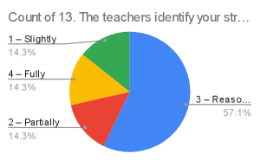
13. The teachers identify your strengths and encourage you with providing right level of challenges. [CN( Mrs. Nagmani)]
13. The teachers identify your strengths and encourage you with providing right level of challenges. [SE(Mr. Shiva Krishna)]
14. Teachers are able to identify your weaknesses and help you to overcome them. [AI(Dr. Srinivasu)v]
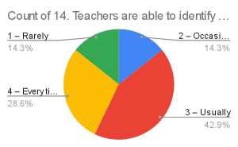
14. Teachers are able to identify your weaknesses and help you to overcome them. [AT(Mrs. Afreen Fatima Mohammed)]
14. Teachers are able to identify your weaknesses and help you to overcome them. [OS(Ms. Sumedha & Dr. Rama KRISHNA)]
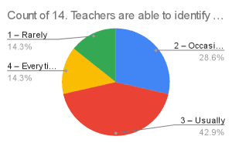
14. Teachers are able to identify your weaknesses and help you to overcome them. [WAD(Mrs. CH. Shruthi)]
14. Teachers are able to identify your weaknesses and help you to overcome them. [CN( Mrs. Nagmani)]
15. The institution makes effort to engage students in the monitoring, review and continuous quality improvement ofthe teaching learning process. [AI(Dr. Srinivasu)]
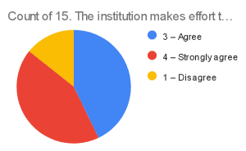
15. The institution makes effort to engage students in the monitoring, review and continuous quality improvement ofthe teaching learning process. [AT(Mrs. Afreen Fatima Mohammed)]
15. The institution makes effort to engage students in the monitoring, review and continuous quality improvement ofthe teaching learning process. [OS(Ms. Sumedha & Dr. Rama KRISHNA)]
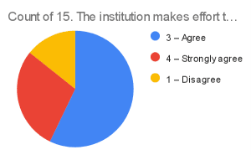
15. The institution makes effort to engage students in the monitoring, review and continuous quality improvement ofthe teaching learning process. [WAD(Mrs. CH. Shruthi)]
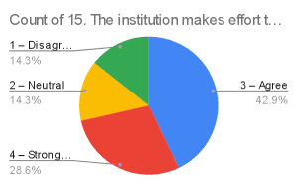
15. The institution makes effort to engage students in the monitoring, review and continuous quality improvement ofthe teaching learning process. [CN( Mrs. Nagmani)]
15. The institution makes effort to engage students in the monitoring, review and continuous quality improvement ofthe teaching learning process. [SE(Mr. Shiva Krishna)]

STUDENT SATIFICATION SURVEY FOR CME VI SEM(2021-22)

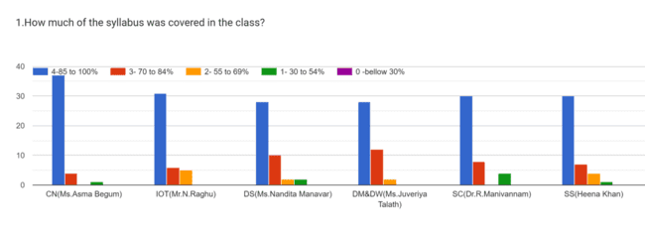
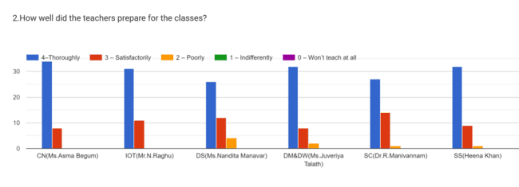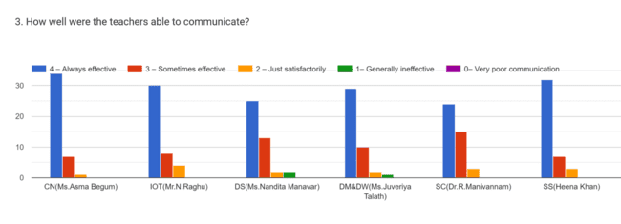
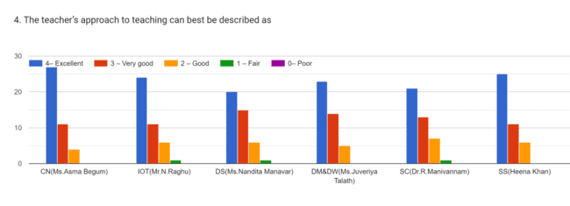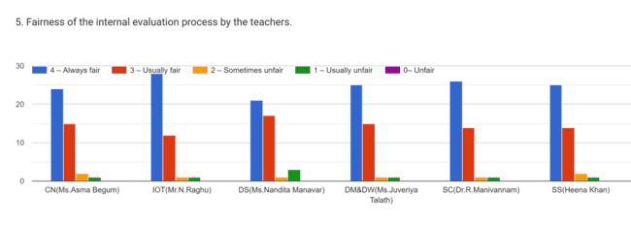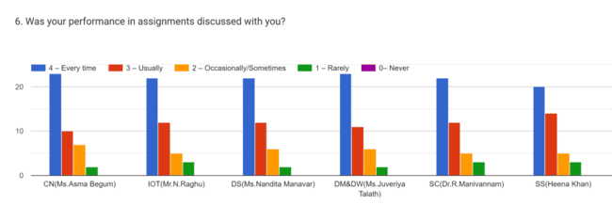
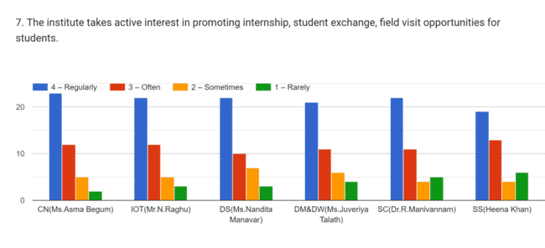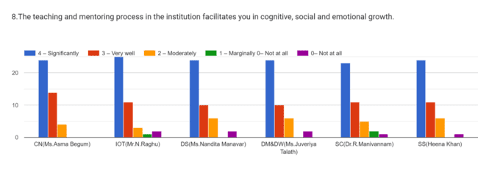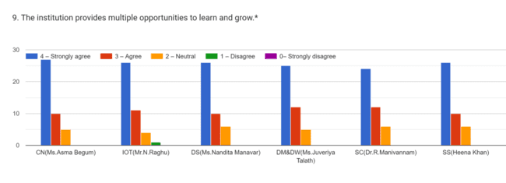
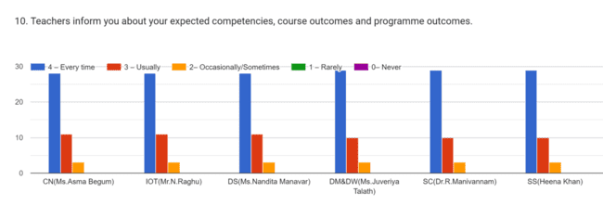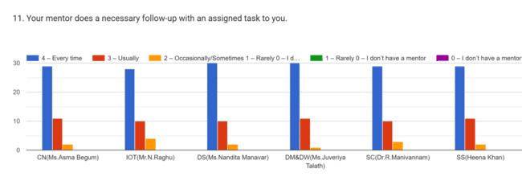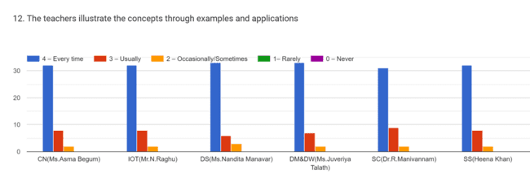
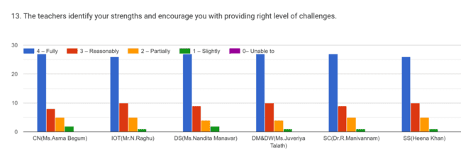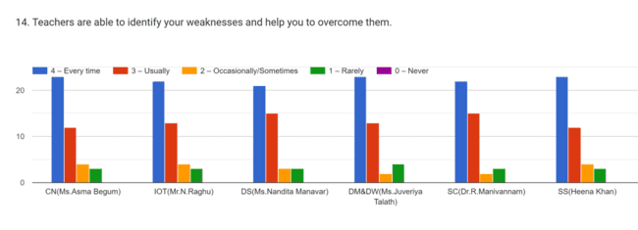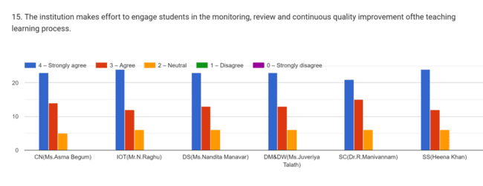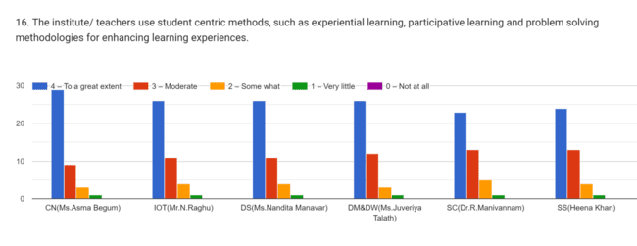
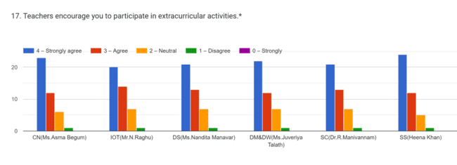
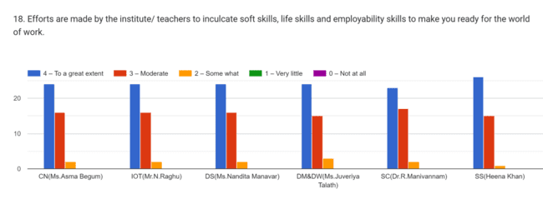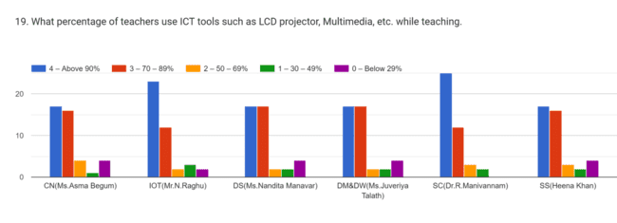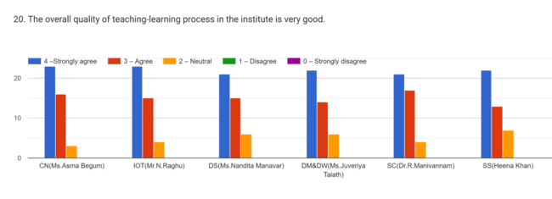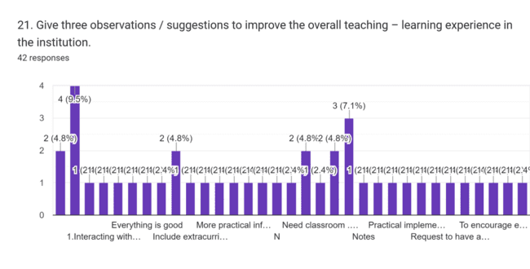

STUDENT SATIFICATION SURVEY FOR CME IV SEM(2021-22)
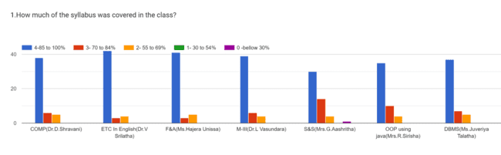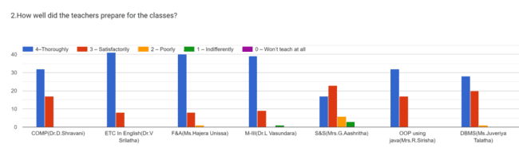
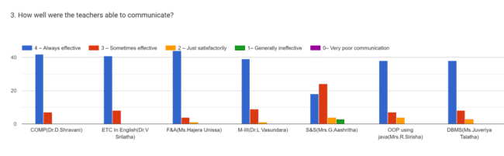
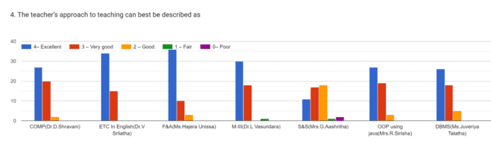

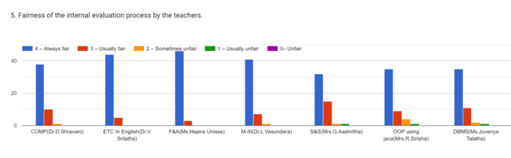
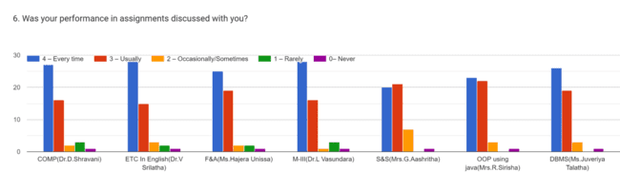
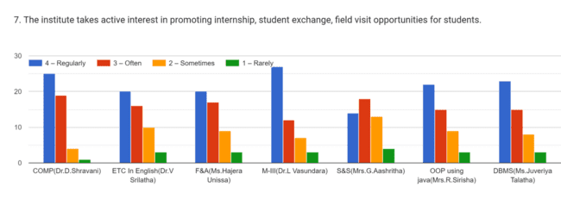
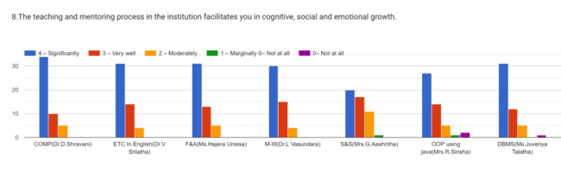
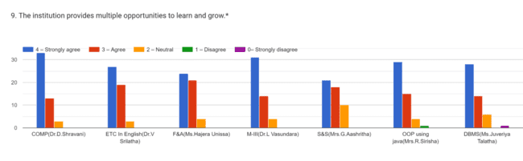
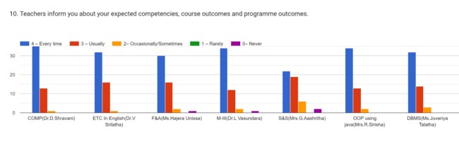
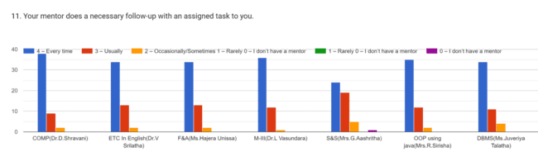
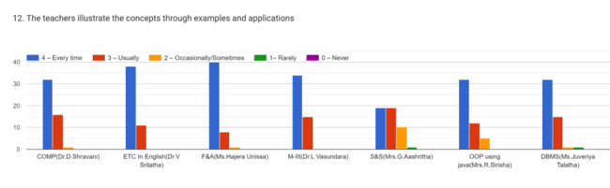
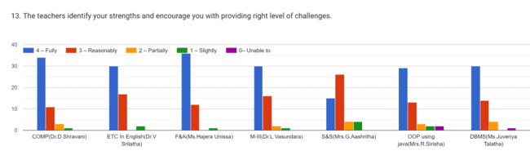
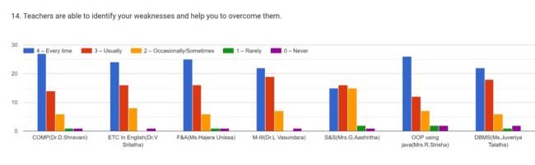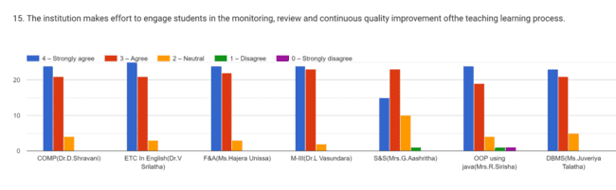
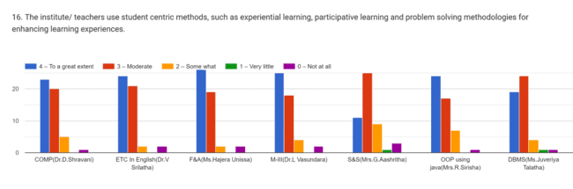
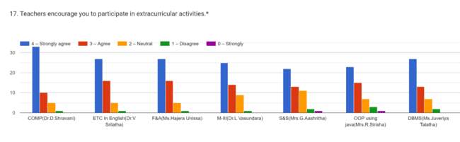
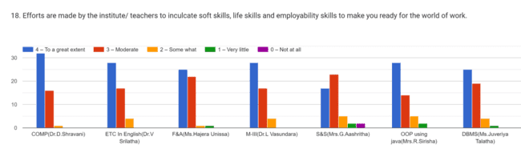
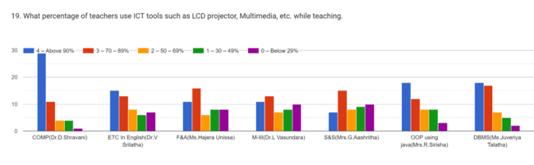
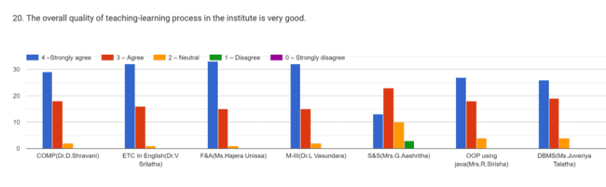
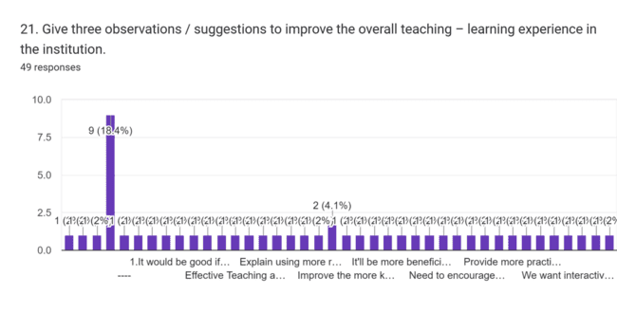

STUDENT SATIFICATION SURVEY FOR AI&DS IVSEM (2021-22)
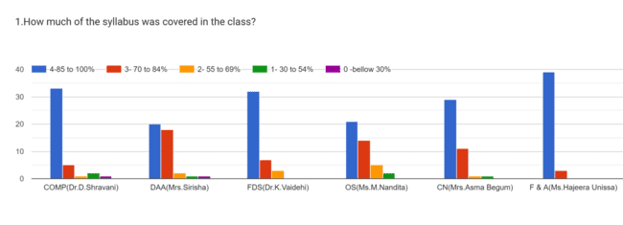
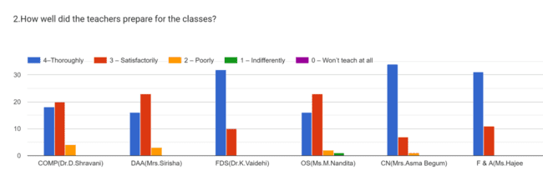
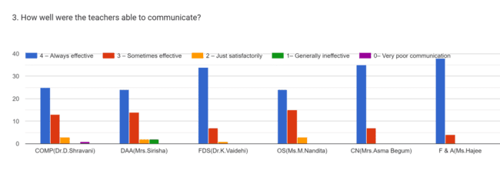
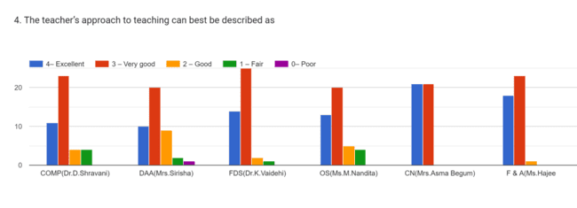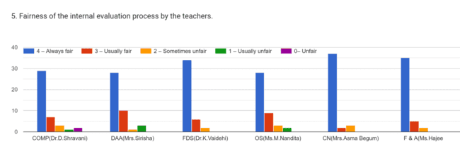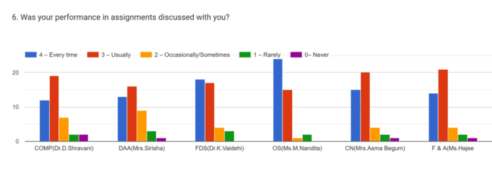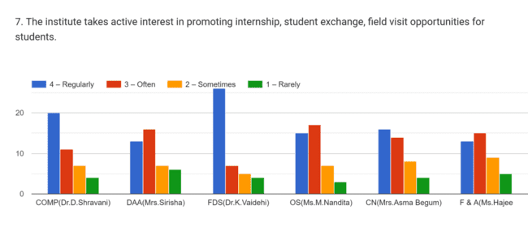

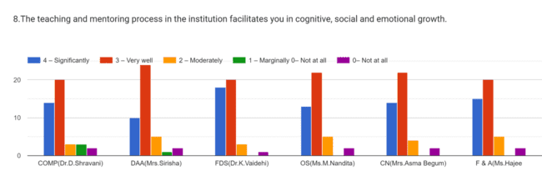
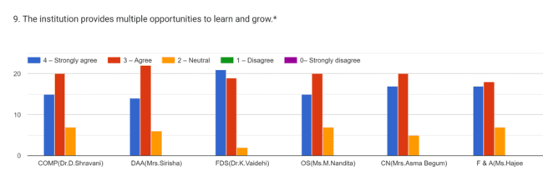
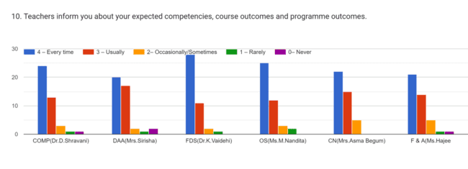

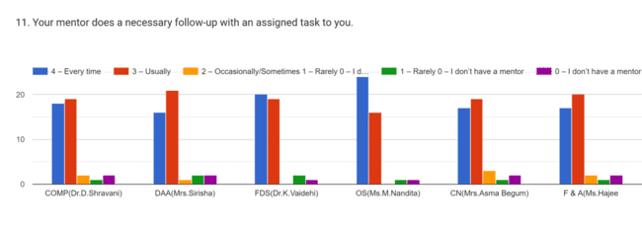
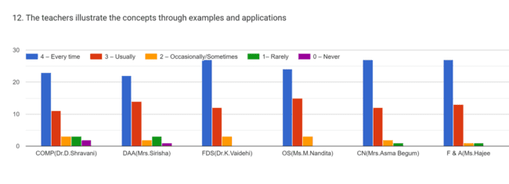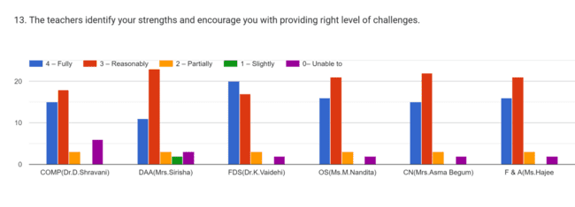
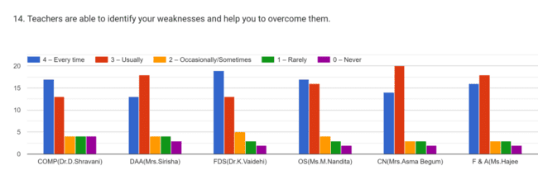
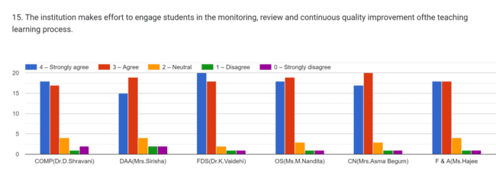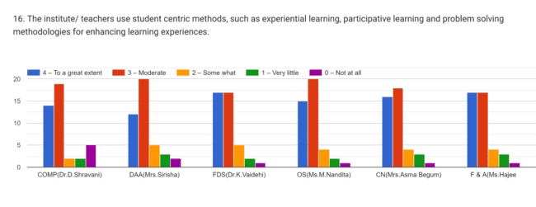
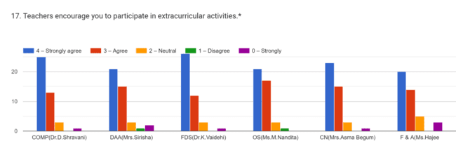
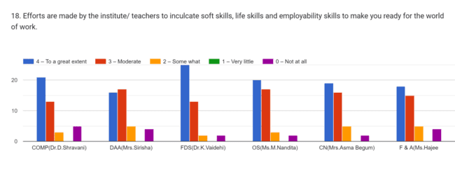
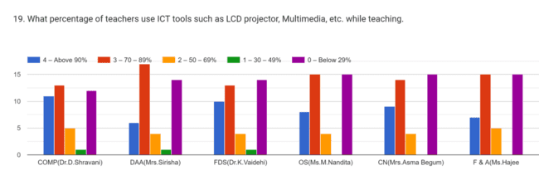
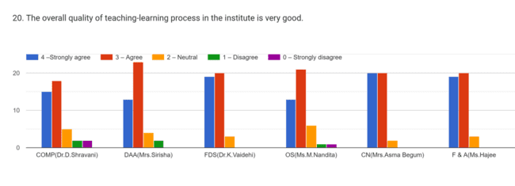
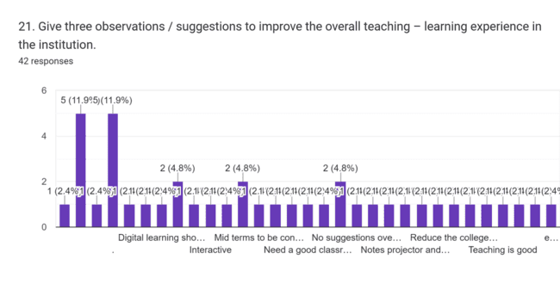

STUDENT SATISFACTION SURVEY
